Agenda Item : 1/01

= application site



Kilby’s Industrial Estate, Bacon Lane, Edgware | P/5810/17

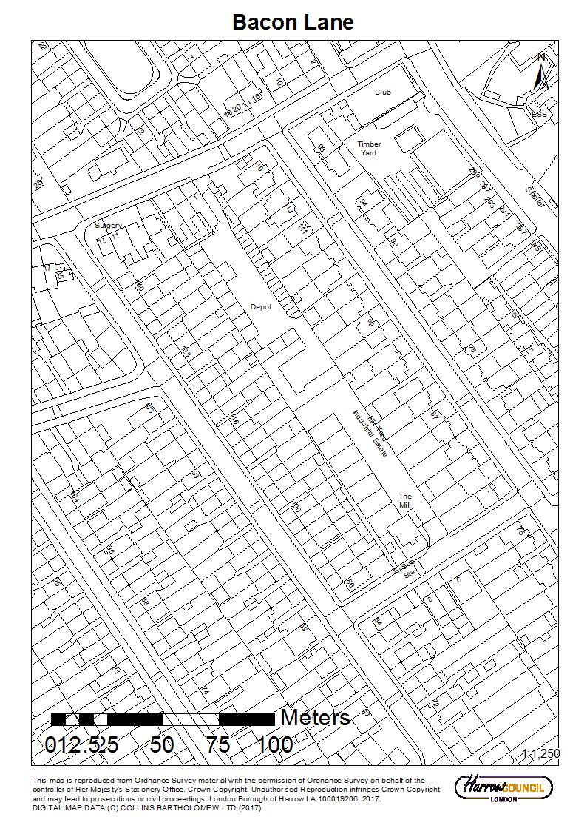

Kilby’s Industrial Estate, Bacon Lane, Edgware | P/5810/17

LONDON BOROUGH OF HARROW

PLANNING COMMITTEE

30th MAY 2018

Application Number: |  | P/5810/17
Validate Date: |  | 29/01/2018
Location: |  | Kilby’s Industrial Estate, Bacon Lane, Edgware
Ward: |  | Edgware
Postcode: |  | HA8 5AS
Applicant: |  | Mr John Polycarpou
Agent: |  | Urbanissta Ltd
Case Officer: |  | Olivier Nelson
Expiry Date: |  | 16/04/2018 (extended expiry date 06/06/2018)
PURPOSE OF REPORT/PROPOSAL

The purpose of this report is to set out the Officer recommendations to the Planning Committee regarding an application for planning permission relating to the following proposal.

Redevelopment to provide 24 houses; associated landscaping and parking; refuse storage

The Planning Committee is asked to:

RECOMMENDATION A

The Planning Committee is asked to:

- agree the reasons for approval as set out in this report, and

- grant planning permission subject to authority being delegated to the Divisional Director of Regeneration, Enterprise and Planning in consultation with the Director of Legal and Governance Services for the completion of the Section 106 legal agreement and other enabling legislation and issue of the planning permission and subject to minor amendments to the conditions (set out in Appendix 1 of this report) or the legal agreement. The Section 106 Agreement Heads of Terms would cover the following matters:

- Provision of offsite affordable housing contribution of £110,000 with a viability review mechanism
- Harrow Employment and Training Initiatives: Contribution of £16,015 towards local training and employment initiatives prior to commencement
- Child Play Space provision contribution
- Local goods and services commitment strategy
- Parking permit restriction
- Carbon offsetting contribution
- External materials strategy
- Travel plan
- Planning Permission monitoring fee: Payment of £5000 administration fee for the monitoring and compliance of the legal agreement.
- Legal fees
RECOMMENDATION B

That if the Section 106 Agreement is not completed by 29th August 2018 or such extended period as may be agreed in writing by the Divisional Director of Planning, the section 106 Planning Obligation is not completed, then delegate the decision to the Divisional Director of Planning to REFUSE planning permission for the appropriate reason.

The proposed development, in the absence of a legal agreement to provide appropriate affordable housing provision that directly relates to the development, would fail to ensure that the development in this location prioritises access by sustainable modes and does not place additional transport stress on the public highway, in accordance with paragraphs 35 and 36 of the National Planning Policy Framework (2012), Policy 6.13 of the London Plan (2016) and Policy DM 43 of the Harrow Development Management Policies Local Plan (2013).
REASON FOR THE RECOMMENDATIONS

The principle of providing a residential development on the application site has been firmly established by identifying the site as an Allocated Site within the Borough. The proposed housing development would bring forward housing provision of a satisfactory mix to provide housing choice to the borough and of an adequate level to ensure suitable accommodation for future occupiers.

It is considered that the proposed buildings would have an acceptable design and external appearance and would not have an undue impact on the character and appearance of the area or the residential amenity of neighbouring occupiers. The proposal would provide appropriate living conditions for the future occupiers of the development. In addition to this, the details submitted in relation to landscaping, boundary treatment, levels, the environmental enhancement scheme and cycle parking are considered to be acceptable.

INFORMATION

This application is reported to Planning Committee as it is a Major Development and therefore falls outside Schedule 1 of the Scheme of Delegation.
Statutory Return Type: | Largescale Major Dwelling development
Council Interest: | N/A
GLA Community Infrastructure Levy (CIL) Contribution (provisional): | £290,620
Local CIL requirement: | £92,470
HUMAN RIGHTS ACT

The provisions of the Human Rights Act 1998 have been taken into account in the processing of the application and the preparation of this report.

EQUALITIES

In determining this planning application the Council has regard to its equalities obligations including its obligations under section 149 of the Equality Act 2010.

For the purposes of this application there are no adverse equalities issues.

S17 CRIME & DISORDER ACT

Policies 7.3.B and 7.13.B of The London Plan and Policy DM1 of the Development Management Polices Local Plan require all new developments to have regard to safety and the measures to reduce crime in the design of development proposal. It is considered that the development does not adversely affect crime risk.

LOCAL GOVERNMENT (ACCESS TO INFORMATION) ACT 1985
BACKGROUND PAPERS USED IN PREPARING THIS REPORT:

- Planning Application
- Statutory Register of Planning Decisions
- Correspondence with Adjoining Occupiers
- Correspondence with Statutory Bodies
- Correspondence with other Council Departments
- Nation Planning Policy Framework
- London Plan
- Local Plan - Core Strategy, Development Management Policies, SPGs
- Other relevant guidance

LIST OF ENCLOSURES / APPENDICES:

Officer Report:
Part 1: Planning Application Fact Sheet
Part 2: Officer Assessment
Appendix 1 – Conditions and Informatives
Appendix 2 – Site Plan
Appendix 3 – Site Photographs
Appendix 4 – Plans and Elevations

OFFICER REPORT

PART 1: Planning Application Fact Sheet

The Site

Address | Kilby’s Industrial Estate, Bacon Lane
Applicant | Mr John Polycarpou
Ward | Edgware
Local Plan allocation | H15 – Hill’s Yard Bacon Lane – (28 homes)
Conservation Area | No
Listed Building | No
Setting of Listed Building | No
Building of Local Interest | No
Tree Preservation Order | No
Other | No

Housing

Density | Proposed Density hr/ha | 409
Density | Proposed Density u/ph | 73
Density | PTAL | 2-3
Density | London Plan Density Range | 200-450 hr/ha
Dwelling Mix | Studio (no. / %) | 0
Dwelling Mix | 1 bed ( no. / %) | 0
Dwelling Mix | 2 bed ( no. / %) | 0
Dwelling Mix | 3 bed ( no. / %) | 10 (42%)
Dwelling Mix | 4 bed ( no. / %) | 14 (58%)
Dwelling Mix | Overall % of Affordable Housing | 0%
Dwelling Mix | Social Rent (no. / %) | N/A
Dwelling Mix | Intermediate (no. / %) | N/A
Dwelling Mix | Private (no. / %) | N/A
Dwelling Mix | Commuted Sum | N/A
Dwelling Mix | Comply with London Housing SPG? | Yes
Dwelling Mix | Comply with M4(2) of Building Regulations? | Yes

Non-residential Uses

Existing Use(s) | Existing Use / Operator | B1/B2 uses
Existing Use(s) | Existing Use Class(es) sqm | 1071 sqm
Proposed Use(s) | Proposed Use / Operator | N/A
Proposed Use(s) | Proposed Use Class(es) sqm | N/A
Employment | Existing number of jobs | N/A
Employment | Proposed number of jobs | N/A

Transportation

Car parking | No. Existing Car Parking spaces | 0
Car parking | No. Proposed Car Parking spaces | 24
Car parking | Proposed Parking Ratio | 1:1
Cycle Parking | No. Existing Cycle Parking spaces | 0
Cycle Parking | No. Proposed Cycle Parking spaces | 49
Cycle Parking | Cycle Parking Ratio | 1:2
Public Transport | PTAL Rating | 2-3
Public Transport | Closest Rail Station / Distance (m) | Burnt Oak / 1150m
Public Transport | Bus Routes | Eight ( Routes : 32, 142, 204, 251, 292, 605, 606, 619)
Parking Controls | Controlled Parking Zone? | No
Parking Controls | CPZ Hours | -
Parking Controls | Previous CPZ Consultation (if not in a CPZ)
Parking Controls | Other on-street controls
Parking Stress | Area/streets of parking stress survey | -
Parking Stress | Dates/times of parking stress survey | -
Parking Stress | Summary of results of survey | -
Refuse/Recycling Collection | Summary of proposed refuse/recycling strategy

Sustainability / Energy

BREEAM Rating
Development complies with Part L 2013? | Yes
Renewable Energy Source / %

PART 2: Assessment

- SITE DESCRIPTION

1.1 The application site comprises approximately 0.33ha of land located between the rear gardens of the residential properties along Vancouver Road and the Chase with the access point from Bacon Lane. In addition, the application site includes three residential properties (nos. 1-5 Bacon Lane), resulting in a rectangular site.

1.2 The application site is currently used for various B1/B2 industrial uses and as lock up garages.

1.3 The surrounding land use is predominantly residential in the form of semi-detached and terraced inter-war housing.

1.4 The application site is located within the Policy sub Area of Edgware and Burnt Oak. It is an identified allocated site (H15) for residential development within the Harrow Site Allocations SPD (2013).

- PROPOSAL

2.1 The application proposes to demolish the existing commercial buildings and the three terrace dwellinghouses on Bacon Lane to construct 24 terraced dwellinghouses.

2.2 The proposed dwellinghouses would be a mixture of ten x three bed six persons and four x four bed six persons. The three beds would have an internal area of 106sqm and the four beds an internal area of 113 sqm.

2.3 The properties would be split into 5 terraces comprising of either 4 or 5 dwellinghouses. One five house terrace would face onto Bacon Lane and the rest would be within the site and in between the rear gardens of the properties on The Chase and Vancouver Road. These would consist of three terraces of five and one terrace of four.

2.4 The properties would all have front and rear gardens. One car parking space and refuse storage would be within the front garden. The rear gardens would be private amenity space for each dwellinghouse.

2.5 Soft landscaping is proposed within the frontage and to the rear of the development.

- RELEVANT PLANNING HISTORY

3.1 A summary of the relevant planning application history is set out in the table below:

Ref no. | Description | Status and date of decision
P/3578/17/PREAPP | Demolition of existing commercial buildings and erection of 25 dwelling houses along with associated parking and bin stores. | Pre application advice issued.
P/5647/16/PREAPP | Demolition of existing commercial building and erection of 44 residential dwellings comprising 8 x 1 bed, 18 x 2 bed & 4 x 3 bed flats, and 6 x 4 bed and 4 x 5 bed houses. | Pre application advice issued.

- CONSULTATION

  - A Site Notice was erected on 01/02/2018, expiring on 22/02/2018.

4.2 Press Notice was advertised in the Harrow Times on the 01/02/2018, expiring on 22/02/2018.

4.3 The application was advertised as a major application.

4.4 A total of 94 consultation letters were sent to neighbouring properties regarding this application.

4.5 The overall public consultation period expired on 22/02/2018.

4.6 Adjoining Properties

Number of letters Sent | 94
Number of Responses Received | 5
Number in Support | 0
Number of Objections | 5
Number of other Representations (neither objecting or supporting)

4.7 5 objections were received from adjoining residents.

4.8 A summary of the responses received along with the Officer comments are set out below:

Details of  Representation | Summary of Comments | Officer Comments
Mr Alam  124 The Chase | Objects to the application due to:  Height of the proposed buildings and the close proximity to my property  Proposal would lead to loss of privacy to my garden  Proposal would compromise light and obstruct view from my property  Proposal would devalue my property  Proposal would lead to congestion with visitors increasing parking pressures to the area.  Issue with safety, increase housing could lead to fire risk | Issues relating to height of the proposal are assessed  in section 6.7.13 of this report.  Issues relating to light are assessed  in section 6.7.12 -13 of this report.  Issues relating to parking  n are assessed  in section 6.8.1 – 6.8.3 of this report.
P Varsani  134 The Chase | Loss of light and overshadowing  Overlooking/ loss of privacy  Traffic generation will be high especially due local surgery and primary school.  Noise and disturbance resulting from use | Issues relating to loss of privacy are assessed  in section 6.7.11 of this report.  The surrounding area is residential it is not considered that additional residential uses would be over and above the neighbouring properties.
S Patel  136 The Chase | Loss of light and overshadowing  Overlooking/ loss of privacy
A Featherstone  128 The Chase | There is an alleyway running at the bottom of the gardens in The Chase. This gives access from the chase through the back gardens. How is the going to change? | Noted.
Mr I Wyper  120 The Chase | Proposal would devalue my property  Issue with safety, the back is at risk with loss of brick partition.  Proximity of 20 new build houses backing onto my property. An invasion of privacy.  The height of the new build would result in loss of light.  Proposed parking most houses have 2 vehicles or more, the proposal will prevent emergency services entering the new build area. | Valuation of properties is not a material planning consideration.  Concerns in relation to safety would be covered by the building regulations.

4.9 Statutory and Non Statutory Consultation

4.10 The following consultations have been undertaken:

LBH Environmental Health
LBH Highways
LBH Planning Policy
LBH Design
LBH Conservation Officer
LBH Tree Officer
LBH Landscape Architects
LBH Waste Officer
TFL
Environment Agency
Affinity Water
Natural England
Designing Out Crime Officer, Metropolitan Police Service
Thames Water Authority
Campaign for a Better Harrow Environment

4.11 Internal Consultation

4.12 A summary of the consultation responses received along with the Officer comments are set out in the Table below.

Consultee | Summary of Comments | Officer Comments
Planning Policy | The application site is an allocated site within the Allocation SPD (2013) under H15.  It is acknowledged that there is a steady reduction in employment floorspace, and the draft London Plan (2017) identifies that Harrow should retain capacity.  It is noted that the site is not designated for employment use, and therefore would be the first standard to be released. The site has been through a sequential process, which has been identified as being acceptable to be released subject to achieving a satisfactory housing quantum.  The loss of the site as a B1/B2 is acceptable given the allocation of the site, and the loss of the employment floorspace would not be resisted in this instance.
Highways | No objection to the proposal.  Proposal is within a Ptal 2/3 location. The shopping areas of Burnt Oak and Edgware are within a reasonable walking distance.  The existing use generates a fairly high number of vehicle trips per day (364) this is likely to reduce to (122) by this proposal.  Ratio of 1:1 parking is acceptable. In the event of a possible overspill permit restrictions should be secured via s106 agreement.  All vehicles would be able to enter and exit in forward gear.  Details of the electrical charging points and type of cycle storage should be secured by pre-occupation condition.  The submitted construction method statement is good.
Drainage | The site is within Critical Drainage Area 15 (Edgware)  The Flood Risk Assessment submitted is satisfactory.  Measures to control the rate and volume of surface water runoff, to ensure separation of surface and foul water systems.
Economic Development | The site has been identified as a housing site in the Local Plan, however we are concerned about the loss of employment space given that there has been a steady reduction of employment space in the borough over a number of years such that there is now a limited amount of employment space available in the borough.  Given the loss of employment space, we would expect a planning (section 106) contribution towards employment and training or business support activities, based on job loss.
Landscape | If you are minded to approve this application the following hard and soft landscape conditions would be required:  Landscaping to be approved, include masterplan, hard and soft landscape details.  Soft landscape  Boundary treatment  Levels  Landscaping scheme  Management and maintenance plan

External Consultation

Consultee | Summary of Comments | Officer Comments
Metropolitan Police Service – Design out Crime Officer | A condition should be added stating that the development would achieve Secure by Design accreditation | The application can achieve the physical security requirements of Secured by Design

- POLICIES

5.1 Section 38(6) of the Planning and Compulsory Purchase Act 2004 requires that:

‘If regard is to be had to the Development Plan for the purpose of any determination to be made under the Planning Acts, the determination must be made in accordance with the Plan unless material considerations indicate otherwise.’

5.2 The Government has issued the National Planning Policy Framework [NPPF] which consolidates national planning policy and is a material consideration in the determination of this application.

5.3 In this instance, the Development Plan comprises The London Plan 2015 [LP] and the Local Development Framework [LDF]. The LDF comprises The Harrow Core Strategy 2012 [CS], Harrow and Wealdstone Area Action Plan 2013 [AAP], the Development Management Policies Local Plan 2013 [DMP], the Site Allocations Local Plan [SALP] 2013 and Harrow Local Area Map 2013 [LAP].

5.4 A full list of all the policies used in the consideration of this application is provided as Informative 1 in Appendix 1 of this report.

6.0 ASSESSMENT

6.1 The main issues are;

Principle of the Development
Regeneration
Affordable Housing
Design, Character and Appearance
Residential Amenity and Accessibility
Housing Supply, Density and Overall Housing Mix
Traffic, Parking and Drainage
Impacts on Trees and Biodiversity
Sustainability
Contaminated Land

6.2 Principle of Development

6.2.1 The adopted National Planning Policy Framework [NPPF] has brought forward a presumption in favour of “sustainable development”. The NPPF defines “sustainable development” as meeting the needs of the present without compromising the ability of future generations to meet their own needs. The NPPF sets the three strands of sustainable development for planning to be; to play an economic, social and environmental role. The NPPF, following the deletion of the Planning Policy Statements and Guidance Notes, continues to encourage the effective use of land by reusing land that has been used previously, recognising that “sustainable development” should make use of these resources first.

6.2.2 Harrow’s Core Strategy establishes a clear vision for the management of growth in the Borough over the Local Plan period (to 2026) and a framework for development in each district of the Borough. Policy CS1(A) directs growth to town centres and strategic, previously-developed sites and provides for that growth to be managed in accordance with the sub area policies. Policy CS8 I commits the Council to bring forward the ’Redevelopment of identified, previously developed sites to collectively contribute at least 1,229 homes towards the Borough’s housing allocation, set out in Core Policy CS1 H will be encouraged”. To this end, the key diagram for the Edgware and Burnt Oak sub area identifies this location for future housing and the site is formally allocated as such in the Site Allocations Local Plan document.

6.2.3 Within the context of planned growth across London, the proposal therefore accords with Harrow’s vision for the development of the Borough as a whole and for the Edgware and Burnt Oak sub area. The proposal would make a contribution to forecast requirements for new housing in the Borough over the plan period.

6.2.4 Turning to the detail of the site’s allocation, it is included as Site H15 of Harrow’s Site Allocations Local Plan document. The site allocation also seeks residential development. The site has been through a sequential test and providing an acceptable quantum of housing is provided, its loss would therefore be considered acceptable.
6.2.5 Kirby’s Industrial estate is an allocated site within the Site Allocations Local Plan for residential development. On this basis it is considered that the proposed residential development would be acceptable in principle. The proposed additional dwellinghouses along Bacon Lane would facilitate the wider redevelopment of the site. Even though the proposed intensification of these dwellinghouses would constitute Garden Land Development as per the adopted Garden Land SPD, it is considered that the departure from planning policy would be justifiable in this instance, given that the redevelopment would help bring forward an allocated site for development. On this basis it is considered that the proposed residential use on the site would be acceptable, subject to further detailed character, design and amenity considerations.

6.2.6 The commentary notes that the allocated site is earmarked to provide for a minimum of 28 homes (net 28). The proposal is for 24 homes. Within the strategic policy context, the indicative status of the housing capacity figure included in the site allocation and taking into account the approach to the design and layout of the scheme, the provision of 24 homes is not inappropriate. The form of the development would comprise five separate blocks of terrace accommodation, with one block fronting onto Bacon Lane and the rest within the parcel of land that sits in between Bacon Lane, The Chase and Vancouver Road.

6.2.7 The principle of the development is therefore considered acceptable.

6.3 Regeneration

6.3.1 The proposal would redevelop a “windfall site” that would to provide additional Council Housing Stock and create local jobs during the construction, with its 2-3 PTAL level and the scale and intensity of surrounding development, the site is currently considered to be underutilised. The London Borough of Harrow published a Regeneration Strategy for 2015 – 2026. The objective of this document is to deliver three core objectives over the plans life, which include;

- Place; Providing the homes, schools and infrastructure needed to meet the demands of our growing population and business base, with high quality town and district centres that attract business investment and foster community engagement;
- Communities; Creating new jobs, breaking down barriers to employment, tackling overcrowding and fuel poverty in our homes and working alongside other services to address health and welfare issues;
- Business; Reinforcing our commercial centres, promoting Harrow as an investment location, addressing skills shortages, and supporting new business start-ups, developing local supply chains through procurement.

6.3.2 Whilst it is acknowledged that the proposed development would not address all of the aspects noted in the above bullet points, it would achieve the overall aspiration of regeneration of the Borough by helping to meet the demands of a growing population. Furthermore, the proposed development aid in the regeneration of the Borough as it would result in new terrace dwellinghouses within the neighbourhood, and would help to promote housing choice, meet local needs, and to maintain mixed and sustainable communities. A contribution would be secured by way of planning obligation for contribution towards employment and training or business support activities as a result of the loss of the B1/B2 uses which currently occupy the site. This would help to regenerate the local community in relations to creating new jobs and improving skill shortages.

6.4 Affordable Housing

6.4.1 The NPPF defines affordable housing as: social rented, affordable rented and intermediate housing, provided to eligible households whose needs are not met by the market. Intermediate housing is defined as homes for sale and rent provided at a cost above social rent but below market levels.

6.4.2 The strategic part of London Plan Policy 3.11 calls for 60% of affordable housing provision to be for social and affordable rent and for 40% to be for intermediate sale or rent, and gives priority to the provision of affordable family housing. However, London Plan Policy 3.12 – which is a planning decisions policy - requires the on-site provision of the maximum reasonable amount of affordable housing from private residential developments.

6.4.3 The London Plan’s housing policies are supplemented by the Mayor’s Housing SPG (2016). In relation to affordable housing policies, the tone of the SPG is to further emphasise the need for policies to be applied in a manner that maximises output and, having regard to viability, to encourage not restrain housing development.

6.4.4 Having regard to Harrow’s local circumstances, Policy CS1 (J) of the Core Strategy sets a Borough-wide target for 40% of all homes delivered over the plan period (to 2026) to be affordable, and calls for the maximum reasonable amount to be provided on development sites having regard to the following considerations:
- the availability of public subsidy;
- the housing mix;
- the provision of family housing;
- the size and type of affordable housing required;
- site circumstances/scheme requirements;
- development viability; and
- the need to meet the 40% Borough-wide target.

6.4.5 Policy DM24 (Housing Mix) of the Development Management Policies Local Plan document supports proposals that secure an appropriate mix of housing on the site. The policy undertakes to have regard inter alia to the target mix for affordable housing set out in the Planning Obligations SPD and the priority to be afforded to the delivery of affordable family housing. Harrow’s planning obligations require that the affordable units are split: 60% affordable rent to 40% shared ownership.

6.4.6 The proposed development would provide for 24 residential units within the site. Policy 3.13A (Affordable Housing Thresholds) of the London Plan (2016) requires that any development which has the capacity to provide 10 or more homes should provide an affordable housing contribution. Core Strategy policy CS1J states that ‘the Council will aim for a Borough-wide affordable housing target of 40% of the housing numbers delivered from all sources of supply across the Borough’. Policy CS1.J goes on to say that the Council will seek the maximum reasonable amount of affordable housing on all development sites having regard to a number of criteria, including development viability.

6.4.7 The development proposed here would contribute towards the housing stock and increase the choice of housing in the borough and would therefore find some support in policies 3.5 and 3.8 of The London Plan as detailed above. As mentioned previously, the site is allocated and as such is earmarked to bring forward a housing development.

6.4.8 The Council recognise that not in all circumstances it is viable to provide affordable housing targets within a scheme. Where this cannot be provided on site, a robust viability assessment must be provided to demonstrate that the proposed scheme cannot viably provide this requirement. The proposed development offered a zero provision of affordable housing as part of the scheme. The applicant has submitted a Financial Viability Appraisal to support the zero provision of affordable housing to the boroughs stocks. The submitted information within the Financial Viability Assessment contains market sensitive information, and as such is unable to be assessed in a public forum. Notwithstanding this, the submitted information has been independently reviewed and tested to ensure that the zero provision of affordable housing is the maximum reasonable affordable housing that can be made as part of the proposed scheme.

6.4.9 The independent assessment of the Financial Viability Assessment concluded that the proposed scheme could indeed reasonably provide a payment in lieu of offsite affordable housing contribution, contrary to what was detailed within the applicants appraisal. The independent review concluded that the proposed development could reasonably provide a financial contribution of £110,000. The financial contribution would be less than the price of one dwellinghouse however this could be used for off-site affordable housing. Negotiations with the applicant have since resulted in an agreement of an affordable housing provision which would be secured by way of a section 106 agreement.

6.4.10 Monetary contributions in-lieu of on-site affordable housing are pooled and used by the Council’s Housing Service to provide additional affordable housing in the borough. Under the Council’s Planning Obligations and Affordable Housing SPD, monetary contributions can be spent on (but not limited to) providing affordable housing through delivery of conventional new affordable housing, delivery of private rented housing that is affordable to people in housing need on the Council’s housing register, estate regeneration, bringing long term vacant properties back into use, and acquisition of existing properties. Whilst the preference is that affordable housing is provided on the site to which the planning application relates, monetary contributions provide flexibility in a number of circumstances where: it is not possible / practical to provide affordable housing on site (this application site), it can be used to secure a higher level of provision on an alternative site, it better addresses priority needs (especially for affordable family housing on an alternative, more suitable site) or where there is already a significant amount of affordable housing in an area.

6.4.11 For these reasons, the proposed development would accord with the spatial development strategy for the borough set out in the Core Strategy, whereby providing a development within the borough that would be in a coherent, efficient and effective manner, according with National Planning Policy Framework (2012), policy 3.5A of The London Plan (2016) and policies CS1.A and CS1.B of the Harrow Core Strategy (2012.)

6.4.12 The proposed development would therefore meet the strategic housing aim for the borough and accord with policy 3.13 of the London Plan (2016), Policy CS1.J of the Harrow Core Strategy, policies DM24 and DM50 of the Harrow Development Management Policies Local Plan (2013) and the Supplementary Planning Document: Planning Obligations and Affordable Housing (2013).

6.5 Design, Character and Appearance

6.5.1 The NPPF advises at paragraph 58 that planning policies and decisions should aim to ensure that developments optimise the potential of the site to accommodate development and respond to local character and history and reflect the identity of local surroundings and materials.

6.5.2 The London Plan (2016) Policy 7.4B states, inter alia, that ‘all development proposals should have regard to the local context, contribute to a positive relationship between the urban landscape and natural features, be human in scale, make a positive contribution and should be informed by the historic environment’. The London Plan (2016) Policy 7.6B states, inter alia, that all ‘development proposals should; be of the highest architectural quality, which complement the local architectural character and be of an appropriate proportion composition, scale and orientation’.

6.5.3 Paragraph 4.6 of the Council’s adopted Residential Design Guide SPD (2010) states that ‘the design and layout of new development should be informed by the pattern of development of the area in which it is situated. Furthermore, Paragraph 4.7 goes on to state that ‘the design and layout of new development should recognise the character of the area in which it is situated in…and respond to the positive features of that character’. Paragraph 4.16 of the SPD makes clear that development proposals should recognise the scale, massing and roof form of the surrounding environment and should be appropriate in relation to other adjoining buildings and in the street

6.5.4 The surrounding land use is characterised by two-storey semi-detached and terraced inter-war residential housing. It is considered that the principle of a contemporary interpretation of suburban post/mid-war terraced housing would be acceptable. The massing of the buildings which would be in keeping with the neighbouring dwellinghouse would be in keeping with the locality. Whilst it could be considered the scheme is undeveloped given the allocation proposed figure of 28 units and the provision proposed of 24 units, this is considered acceptable due to the size and quality of accommodation proposed.

6.5.5 The proposed scheme has been developed following pre-application discussions and has been reduced from 25 to 24 dwellinghouses. The proposed development would consist of five separate terrace blocks of dwellinghouses within the site, which would provide an ‘T’ shape within the site. Five houses would front Bacon Lane a public highway, with the rest behind and within the site. Car parking spaces would be located to within the front gardens of the properties, an access road from bacon Lane into the site would lead to the private residential road for the new dwellinghouses.

6.5.6 The proposed five terrace dwellinghouses which would front Bacon Lane would be two storey with habitable accommodation in the roof. This is consistent with the general scale of housing in the surrounding area. The two end terraces would be three bedroom six person houses and the three mid-terraces would be 4 bed six person houses. The other proposed terrace would follow a similar pattern with the end terraces being three bed six person houses and the mid terraces being four bed six person houses. The three bedroom dwellinghouses would have front dormers and the four bedroom dwellinghouses would have front and rear dormers in order to accommodate two bedrooms at roof level.

6.5.7 The dwellinghouses fronting on Bacon Lane would respect the established building line and ridge heights of this frontage and are considered acceptable with respect to scale. The design of the buildings within the site seeks to build on the traditional character of the surrounding dwellinghouses. The proposed materials would be brick and masonry external skin, with double glazed aluminium windows. The dwellinghouses would be spaced out form one another in an acceptable manner with separation distances of 1.5m between the dwellinghouses and the shared boundaries. The proposed dwellinghouses within the site would not be readily visible from the public highway.

6.5.8 The scheme would provide a brick built development with clean and basic elevations. The fenestration would be of a similar size and would be banded together. The dormers would follow the pattern of fenestration on the front and rear elevation of the dwellinghouses. The proposed plans and elevations do not clearly demonstrate what this finish would be, and as such it is considered appropriate to request further information on this element through planning condition.

6.5.9 Each of the proposed blocks would have a hipped roof, with dormers to assist in providing a suitable level of accommodation within the roof space of future occupiers. The proposed roof form, being gabled would be an acceptable roof form in the locality which is predominantly hipped. The proposed roof form, which provides accommodation within the roof space, would ensure that the bulk of the development remains proportionate and not overbearing within the site .

6.5.10 As mentioned previously, it is proposed to provide accommodation within the roof space. To ensure satisfactory living accommodation for future occupiers (to be assessed in detail later), Dormers are proposed in the front and rear slopes, no side dormers are proposed. There would be dormers only on the front elevations of the end terrace dwellinghouses which would help to reduce the cluttered feel of having too many dormers. Furthermore, the number and siting of the proposed dormers would ensure that they would not appear cluttered or unsightly from within the site or wider streetscene.

6.5.11 The materials palette has been simplified to provide a much more basic development. It is proposed to erect the new build primarily from brick, which is considered to be appropriate. However, it is important that the colour and texture of the brick is appropriate for the scale of the building and the surrounding area. Accordingly, it is considered reasonable to attach a condition requiring further details on this detail. Furthermore, a condition has been attached to request details of the materials used it the remainder of the external surfaces of the proposed development.

6.5.12 The proposed five terrace dwellinghouses on Bacon Lane would be accessed directly from the street. The other properties within the development would be accessed via a front entrance which would be a new road off Bacon Lane. This would be open and would allow open access to the site and free movement. The primary access point off Bacon Lane provides access to car parking in front gardens of the proposed dwellinghouses. Parking and other traffic related matters are to be assessed under section 6.8 of this appraisal.

6.5.13 The proposed PTAL rating of 2/3 has led to proposal having a car parking ratio of 1:1. As such one car parking space is proposed for every dwellinghouse. The proposed hardstanding in the front gardens of the dwellinghouses would be primarily for the parking of cars. The rest of the front garden would have refuse storage and cycle storage with some planting just above. Notwithstanding the above, a condition is attached to seek further detail on some hard landscaping features such as boundary treatment, fences, gates, brick walls and railings. Subject to such a condition, it is considered that the proposed hard landscaping is satisfactory.

6.5.14 The proposed soft landscaping details and plans in the main are considered acceptable. The proposed plants over the bin stores are in relatively small plots and these should be increased in size to provide denser permanent planting structures that are more robust and as such more likely to survive. A planting specification and planting plans would be secured by condition. The proposed design of the roof which is part flat roof provides an opportunity to provide a green roof specification. This would be secured by way of planning condition.

6.5.15 The proposed redevelopment should be designed to reduce opportunities for criminal behaviour and contribute to a sense of security as required by policy 7.3B of The London Plan and policy DM 2 of the Development Management Policies Local Plan (2013). It is advised that the redevelopment of the site takes into account the Secure by Design principles and seeks accreditation. A condition has been added requesting that the proposal is in line with these principles.

6.5.16 Subject to the conditions mentioned above, it is considered that the external appearance and design of the buildings together with the proposed landscaping scheme are consistent with the principles of good design as required by the National Planning Policy Framework (2012). The resultant development would be appropriate in its context and would comply with policies 7.4B and 7.6B of The London Plan (2016), Core Policy CS1(B) of the Harrow Core Strategy, policy DM1 of the Council’s Development Management Policies Local Plan and the Council’s adopted Supplementary Planning Document – Residential Design Guide (2010), which require a high standard of design and layout in all development proposals.

6.6 Housing Supply, Density and Overall Housing Mix

6.6.1 Paragraph 48 of the NPPF reminds local planning authorities that housing applications should be considered in the context of the presumption in favour of sustainable development.

6.6.2 London Plan and Local Plan policies on housing development must be viewed in the context of the forecast growth across London and Harrow’s spatial strategy for managing growth locally over the plan period to 2026. These are set out in the Principle of Development section of this report (above). The proposal’s 24 home contribution to housing supply ensures that this strategic site makes an appropriate contribution to the Borough’s housing need over the plan period to 2026 and to fulfilling the Core Strategy’s target for the Edgware and Burnt Oak sub area, as well as modestly exceeding the housing capacity figure attributed to the site in the Site Allocations Local Plan document.

6.6.3 London Plan Policy 3.4 seeks to optimise housing output from development by applying the sustainable residential quality density matrix at Table 3.2 of the Plan. Supporting text to the policy makes it clear that the density matrix is only the start of planning for housing development and that it should not be applied mechanistically. Further guidance on how the matrix should be applied to proposals is set out in the Mayor’s Housing SPG (2016).

6.6.4 The application site area is 0.328 hectares and it has a public transport accessibility level (PTAL) score of 2/3 indicating a poor/moderate level of public transport accessibility. Within the definitions of the London Plan density matrix, the site is considered to have an urban setting. The proposal, taken as a whole, equates to a density of 73 units per hectare and of 408 habitable rooms per hectare. These densities fall well within the overall matrix ranges for urban setting sites with PTAL 2-3, being between 45-120units per hectare and 200-450 habitable rooms per hectare. However, as noted above, the matrix is only the starting point for considering the density of development proposals. The following is a breakdown of the proposed housing mix across the scheme.

Table 2: Detailed Housing Mix
Unit Size | No. of Units (Total) | % of All Units
3 Beds: | 10 | 42%
4 Beds: | 14 | 58%
Totals: | 24 | 100%

6.6.5 All the proposed residential units would be dwellinghouses within the development. The table above demonstrates that there would be a satisfactory mix of housing types within the scheme. The proposal would provide 24 family size housing units, which is welcomed.

6.7 Residential Amenity

6.7.1 London Plan Policy 3.5 Quality and Design of Housing Developments sets out a range of criteria for achieving good quality residential development. Part B of the policy deals with residential development at the neighbourhood scale; Part C addresses quality issues at the level of the individual dwelling.

6.7.2 Core Strategy Policy CS1 K requires a high standard of residential design and layout consistent with the London Plan and associated guidance. Policies DM1 Achieving a High Standard of Development and DM27 Amenity Space set out a number of privacy and amenity criteria for the assessment of proposals for residential development.

6.7.3 The submitted Planning Statement and proposed plans confirm that all of the proposed dwellings have been designed to meet the London Plan’s minimum space standards and a condition to ensure this is achieved is recommended. The submitted drawings show that the proposed layouts would make reasonable provision for the accommodation of furniture and flexibility in the arrangement of bedroom furniture.

6.7.4 The SPG seeks to avoid single aspect dwellings where: the dwelling is north facing (defined as being within 45 degrees of north); the dwelling would be exposed to harmful levels of external noise; or the dwelling would contain three or more bedrooms. Policy DM1 Achieving a High Standard of Development undertakes to assess amenity having regard to the adequacy of the internal layout in relation to the needs of future occupiers and, at paragraph 2.15 of the reasoned justification, echoes the SPG position on single aspect dwellings. The proposed dwellinghouses would have habitable rooms located closest to the windows. The proposed dwellinghouses would be dual aspect and light would be afforded to all habitable rooms.

6.7.5 The London Plan calls for a minimum floor to ceiling height of 2.3 metres with 2.5m being the optimum in habitable rooms. The proposed plans indicate that ground, first and second floors would all have a minimum floor to ceiling height of 2.5m. The proposed layouts are functionable and would continue to provide a satisfactory level of accommodation for future occupiers.

6.7.6 Policy DM27 Amenity Space of the Development Management Policies Local Plan document states that the appropriate form and amount of amenity space should be informed by the Mayor’s Housing Design Guide (i.e. the SPG) and criteria set out in the policy.

6.7.7 For private amenity space, the SPG requires a minimum of 5m² per 1-2 person dwelling and an extra 1m² for each additional occupant, and for balconies the SPG specifies minimum dimensions of 1.5m x 1.5m. The proposed development would have private rear gardens paces which exceed the minimum standards set out in the London Plan. The proposal due to being a major development would need to provide an open space and amenity space for children. The Planning Statement states the development would generate 66 children would need 660 sqm of open space. This amount of space cannot be provided on site, as such the applicant has agreed to provide an off-site provision which would be secured by way of a planning obligation. This would be a monetary contribution and all major developments are expected to provide children’s play spaces on site. Where this is not possible as is the case here, an off-site monetary provision is requested. This can sometimes be used to improve child play facilities which are within 100m of the development

6.7.8 A Landscaping Strategy has been submitted and sets out some principles for the hard and soft landscaping of the whole site including the amenity spaces.

6.7.9 The SPG seeks an adequate level of privacy to habitable rooms in relation to neighbouring property, the street and other public spaces. Policy DM1 Achieving a High Standard of Development in relation to privacy has regard to:
- the prevailing character of privacy in the area and the need to make effective use of land;
- the overlooking relationship between windows and outdoor spaces;
- the distances between facing windows to habitable rooms and kitchens; and
- the relationship between buildings and site boundaries.

6.7.10 The proposed development sits in an ‘T’ shape within the site, with five terrace dwellinghouses facing onto Bacon Lane. A conscious design rationale was taken to split the development into five terrace blocks. This assisted in breaking the bulk of the scheme up, whereby ensuring that it does not appear overly dominant within the site or streetscene. In so adopting this design approach, it results in some of the flank and rear elevations of the individual blocks facing each other within the development, each which would have flank windows within them.

6.7.11 It is noted that the four blocks of terrace houses would have windows on the front which would face on the rear gardens of properties on Vancouver Road and windows on the rear elevation facing onto the rear gardens of properties on The Chase. Objections have been received from neighbouring properties in The Chase regarding the proposed terraced properties causing visual impact loss of light, overlooking and loss of privacy. However it is considered that given that these properties are sited in excess of 21m from the proposed development there would be no undue impact with regard to outlook and visual impact. The proposed terrace houses would have rear facing windows at first floor level which would offer views of the rear gardens of these properties. However given the separation distance it is not considered that there would be unreasonable in this suburban location.

6.7.12 Further objections have been received regarding the impacts of the proposed dwellinghouses on loss of light to the neighbouring properties on the surrounding roads. This element of the proposal would not interrupt a 45° line drawn from the nearest corner of the neighbouring properties and therefore it is considered that there is no undue impact with regard to loss of light. The properties which are likely to be affected are the properties on Vancouver Road and The Chase. The submitted daylight and sunlight report indicates that the properties located between 114 to 140 The Chase would not be affected by the proposed scheme. This is due to all of these neighbouring properties being located approx. 20 metres away from the proposed development. The report also states that the proposed scheme would not impact the properties along Vancouver Road (no. 97 – 119).

6.7.13 The proposed development is highlighted as having a potential to impact on the neighbour at no. 7 Bacon Lane. The proposed terrace fronting Bacon Lane is considered to have some impact on this neighbour. The property at no. 7 has fenestration namely windows at ground and first floor level on the flank elevation of the property. The proposed dwellings fronting Bacon Lane would not exceed the maximum ridge of this neighbour however the proposed terrace would be positioned 0.8m closer to the boundary with no. 7. The positioning of this new building form may impact on this neighbour. The window at first floor level of no. 7 is obscure glazed and is not to a habitable room as such the extension close to the boundary with this window is not considered to be detrimental. The window at ground floor level at this neighbour is the one likely to be affected. The daylight and sunlight report reviewed the position of the new dwellinghouses in relation to this neighbour and considered that this window at no. 7 would still receive an acceptable amount of sunlight in line with BRE guidelines. As such the proposed development is therefore considered appropriate for the site and complies with the BRE guidelines. The report concluded that the rear gardens of the neighbouring properties on The Chase and Vancouver Road would not receive a negative change in daylight and sunlight levels to existing occupants as a result of the proposal.

6.7.14 Overall it is considered that the proposed development given the distance from neighbouring residential properties both within the estate and the surrounding residential streets there would be no undue impact on residential amenities of neighbouring properties.

6.8 Traffic and Parking

6.8.1 The proposal would make provision for 24 parking spaces. The proposed level of parking at a ratio of 1:1 is acceptable considering the size of proposed dwellings and the poor/moderate PTAL location. There is the possibility of overspill parking taking place in the roads surrounding the development site, however the suggestion to permit restrict these properties will assist with limiting this activity. The permit restriction for the new dwellinghouses would be secured via s106 agreement. All the vehicles would be able to enter and exit in a forward gear. Refuse vehicles would be able to enter the site on collection day.

6.8.2 In support of the current planning application, a Transport Statement has been submitted in an attempt to demonstrate that the proposed development would not unacceptably harm the safety and free flow of the public highway. The proposed development would result in the demolition of 3 terrace dwellinghouses, each which are served by an individual dropped kerb onto Bacon Lane along with access to the Kilby Industrial Estate. It is noted that there are a number of bus routes and also Burnt Oak tube station (Northern line) in close proximity.

6.8.3 It is noted that a number of objections have been received in terms of the parking concerns, which have been commented on as already being a poor situation within the area. However, and as mentioned previously, the proposed parking quantum would be compliant with the maximum standards as set out within the London Plan. In addition, the quantum of vehicle movements from generated by the site is considered to have an acceptable impact on the capacity of the public highway. Furthermore, the submitted Transport Statement has been reviewed by the Highways Authority who consider that the proposed quantum would be acceptable, and would not unacceptably harm the safety and free flow of the public highway. Accordingly, it is considered that notwithstanding the objections received in relation to parking, the proposed development would have an acceptable impact on the local parking provision, and the safety and free flow of the public highway.

6.8.4 London plan requires that 1 in 5 spaces are electric car charging points. The submitted Transport Statement confirms that the proposal would provide 20% electric car parking spaces and as such is policy compliant in this regard. This would be secured by pre-occupation condition.

6.8.5 The level of cycle parking would be 49 secure cycle storage spaces for the development. This is in line with the London Plan requirement whereby two spaces per unit are required to be provided. Table 6.3 of the London Plan (2016. Subject to an appropriately worded condition to secure this, it is considered that the proposed development would accord with the policies listed above.

6.8.6 The scheme has been amended to remove the proposed gated pedestrian and vehicular access to the site. The scheme as originally proposed was not considered to create a more socially inclusive scheme. It failed to integrate the new homes within the development with the surrounding area. The revision to the scheme showing an open accessible entrance to the new housing would help to create a sustainable movement network within the borough. This would be in line with London Plan Policies 3.5, 7.1 and 7.3. The secure by design accreditation has been added as planning condition.

6.9 Development and Flood Risk

6.9.1 London Plan (2016) Policy 5.13 A states that development should utilise urban drainage systems, unless there are practical reasons for not doing so, and should aim to achieve Greenfield run-off rates. Core Strategy Policy CS 1 U requires development to be managed to reduce flood risk and increase resilience to flood events. Policy DM 10 A of the Development Management Policies Local Plan (2013) gives substantial weight to the achievement of Greenfield run-off rates and part B of the policy sets out the design and layout criteria for major development proposals.

6.9.2 The application site is located within a critical drainage area of Harrow. The submitted Flood Risk Assessment is considered satisfactory. The Drainage Authority have raised no objection to the proposal subject to conditions which are recommended.

6.10 Sustainability

6.10.1 Paragraphs 96-98 of the NPPF relate to decentralised energy, renewable and low carbon energy. Chapter 5 of the London Plan contains a set of policies that require developments to make the fullest contribution to the mitigation of, and adaptation to, climate change, and to minimise carbon dioxide emissions. Specifically, policy 5.2 sets out an energy hierarchy for assessing applications, as set out below:
1) Be lean: use less energy
2) Be clean: supply energy efficiently
3) Be green: use renewable energy

6.10.2 Policy 5.3 seeks to ensure that future developments meet the highest standards of sustainable design and construction, whilst policies 5.9-5.15 support climate change adaptation measures.

6.10.3 The applicant has submitted an Energy Statement, which details the likely energy demands of the proposed development and proposed a strategy to increase energy efficiency. The Energy Statement goes on to investigate measures to reduce the carbon emissions by 36% on site. London Plan policy 5.2 states that residential buildings should be zero carbon in relation to emission rates in 2016 and beyond.

6.10.4 The methodology for the proposed Energy Strategy accords with the hierarchy set out within the London Plan and demonstrates how the minimum savings in carbon emissions against Building Control targets would be achieved on site. The additional of additional green roof to the flats of the proposed terrace would further the reduction in emissions. The use of Photovoltaic Panels would be used to ensure that this reduction would be meet by the development. The proposal would need to be zero carbon and as such the energy statement would need to be revised to illustrate this.

6.10.5 The application site has a 64% shortfall of carbon dioxide and as such this would need to be provided either on site or by way of an off-site financial contribution. There would be a yearly shortfall of 26 tonnes of carbon dioxide and this would have to be offset for a period of 30 years. The cumulative shortfall of years would then provide a figure which would be payable to the council. The contribution would help towards the Harrow Green Grid which I a network of interlinked, multi-purpose open and green spaces with good connections to place where people live and work in Harrow.

6.10.6 It is therefore considered that subject to a condition requiring the Energy Statement to be updated to show the proposed development would be zero carbon, the proposal would accord with the policies listed above. Conditions to this effect have been recommended.

6.11 Contaminated Land

6.11.1 The proposed residential development would see a significant change from the existing hard landscaped commercial use to a residential use with areas of soft landscaping. This would be a sensitive end use and there would be a moderate risk to future end users. A remediation of the underlying soils would be required to reduce the level of risk to future users. Due to the existing use and practices on site, a remediation of the near surface soils is considered necessary to reduce the risk to future ground works and residents. Further work is required in way of a Remediation Method Statement in order for the proposal to be considered acceptable this would be added by way of condition.

7.0 CONCLUSION AND REASONS FOR APPROVAL

7.1 The principle of providing a residential development on the application site has been firmly established by identifying the site as an Allocated Site within the Borough. The proposed housing development would bring forward housing provision of a satisfactory mix to provide housing choice to the borough and of an adequate level to ensure suitable accommodation for future occupiers.

7.2 It is considered that the proposed buildings would have an acceptable design and external appearance and would not have an undue impact on the character and appearance of the area or the residential amenity of neighbouring occupiers. The proposal would provide appropriate living conditions for the future occupiers of the development. In addition to this, the details submitted in relation to landscaping, boundary treatment, levels, the environmental enhancement scheme and cycle parking are considered to be acceptable.

7.3 For all the reasons considered above, and weighing up the development plan policies and proposals, and other material considerations including comments received in response to notification and consultation as set out above, this application is recommended for grant.

APPENDIX 1: Conditions and Informatives

Conditions

- Timing

The development hereby permitted shall be begun before the expiration of three years from the date of this permission.

Reason: To comply with the provisions of Section 91 of the Town and Country Planning Act 1990.

- Approved Drawing and Documents

The development hereby permitted shall be carried out in accordance with the following approved plans and documents: 2411- BACON LANE - SPD - ACCOMMODATION SCHEDULE , 2411- FPAD - SPD000, PROPOSED SITE LAYOUT OVERLAID ON OS SHEET - LOCATION PLAN, PROPOSED SITE LAYOUT PLAN, 2411- FPAD - SPD003, 2411- FPAD - SPD004, 2411- FPAD - SPD005, 2411- FPAD - SPD006, 2411- FPAD - SPD007, 2411- FPAD - SPD008, 2411- FPAD - SPD009, 2411- FPAD - SPD010, 2411- FPAD - SPD011, 2411- FPAD - SPD012, 2411- FPAD - SPD013, 2411- FPAD - SPD014, 2411- FPAD - SPD015, 2411- FPAD - SPD016, 2411- FPAD - SPD017, 2411- FPAD - SPD018, 2411- FPAD - TOPOGRAPHICAL SURVEY, 2411- FPAD - SITE ELEVATIONS SURVEY (1), 2411- FPAD - SITE ELEVATIONS SURVEY (2), 2411- FPAD - EXISTING SITE LAYOUT PLAN, 2411- FPAD - EXISTING SITE LAYOUT PLAN, 2411- FPAD - EXISTING SITE LAYOUT PLAN, 2411- FPAD - EXISTING SITE LAYOUT PLAN, 2411- FPAD - EXISTING SITE LAYOUT PLAN, BACON LANE VIEW, BIRDS EYE VIEW NORTH, BIRDS EYE VIEW SOUTH, DRIVEWAY VIEW, GARDEN VIEW, GROUND FLOOR - TYPICAL 3 & 4 BEDROOM HOUSES, FIRST FLOOR - TYPICAL 3 & 4 BEDROOM HOUSES, SECOND FLOOR - 3 BEDROOM HOUSE, SECOND FLOOR - 4 BEDROOM HOUSE, LLD1210_IS03_Kilbys Industrial Estate_11.01.2018, LLD1210-LAN-DWG-100-02_11.01.2018, LLD1210-LAN-DWG-101-03_11.01.2018, LLD1210-LAN-DWG-102-03_11.01.2018, LLD1210-LAN-DWG-200-02_11.01.2018, LLD1210-LAN-DWG-201-03_11.01.2018, LLD1210-LAN-DWG-202-03_11.01.2018, LLD1210-LAN-SCH-001-03_Planting_11.01.2018, LLD1210-LAN-SCH-002-02_Materials_11.01.2018, LLD1210-LAN-SPE-001-03_11.01.2018, Planning Statement, Design and Access Statement, Kilbys Industrial Estate - Transport Statement January 2018 ref 11012018, FRA ref 17-3265, Air Quality Assessment ref AQA/2348/EAL, Construction Management Plan, CONT7667 Rev 1 Kilbys Industrial Estate - Contamination Assessment Report , DTS7667 Kilbys Industrial Estate - Desktop Study, FACT7667 Factual Report, Daylight, Sunlight & Overshadowing Assessment revised December 2017, Extended Phase 1 Habitat Survey Ref 17-3265, Energy and Sustainability Statement, NIA Ref: BACON LNE,LONDON, AffordableHousingFVABaconLane09.01.18 (1), Appendix 1 Bacon Lane - Order of Cost Estimate 04.12.17 Rev A, Appendix 2 Decontamination works - B000.PTK Bacon Lane Budget A 2017, Appendix 3 Neway Sales Values, Appendix 3a BestPriceGuide, Appendix 4 Valuation report - 1-5 Bacon Lane Edgware HA8 5AS, Appendix 5 GLA Toolkit Summary09.01.18 HA8

Reason: For the avoidance of doubt and in the interests of proper planning.

- Materials

The development hereby approved shall not progress beyond damp proof course level until samples of the materials to be used in the construction of the external surfaces noted below have been submitted to, and agreed in writing by, the local planning authority:
  - external appearance of the buildings;
  - windows and doors
c. refuse and cycle storage area
d. the boundary treatment

The development shall be carried out in accordance with the details so agreed and shall thereafter be retained.

Reason: To ensure that the development achieves a high standard of design and layout and to ensure that the ground surfacing materials are permeable in accordance with Policy DM 1 of the Harrow Development Management Policies Local Plan (2013). To ensure that the works are agreed in time to be incorporated into the development, this is a PRE-COMMENCEMENT condition.

- Permitted Development Restrictions 1
Notwithstanding the provisions of the Town and Country Planning (General Permitted Development) (England) Order 2015 (or any order revoking and re-enacting that order with or without modification), no development which would otherwise fall within Classes A - F in Part 1 of Schedule 2 to that Order shall be carried out without the prior written permission of the local planning authority.

REASON: To safeguard the character of the area by restricting the amount of site coverage and size of dwelling and to safeguard the amenity of neighbouring residents.

- Permitted Development Restrictions 2
The development hereby permitted shall be used for Class C3 dwellinghouse(s) only and notwithstanding the provisions of the Town and Country Planning (General Permitted Development) (England) Order 2015 (or any Order revoking or re-enacting that Order with or without modification), no development within Schedule 2, Part 3, Class L shall take place.

REASON: To enable the Local Planning Authority to fully consider the effects of development normally permitted by the Town and Country Planning (General Permitted Development) Order 2015 to maintain mixed, balanced, sustainable and inclusive communities and in the interests of residential and visual amenity in accordance with Policy DM1 of the Harrow Development Management Policies 2013, Policy CS1(B) of the Harrow Core Strategy 2012, Policy 7.4 of the London Plan 2016 and the Core Planning Principles of the National Planning Policy Framework 2012.

- Landscaping Masterplan

Before any landscaping is carried out within the site, including any works preparatory to such landscaping, a scheme for the hard and soft landscaping masterplan of the whole site shall be submitted to, and agreed in writing by, the local planning authority. Details shall include:
- planting plans (at a scale not less than 1:100), written specification of planting and cultivation works to be undertaken and schedules of plants, noting species, plant sizes and proposed numbers / densities and an implementation programme;
- existing and proposed site levels, clearly identifying changes to landform;
- landscaping scheme – implementation and implementation programme, including a period of 5 year period for replacements of soft landscape;
- details of hard surface materials;
- details of all boundary treatment, including fences, means of enclosure and gates; and
- details of management and maintenance objectives and a programme for all of the communal landscape areas;
- tree planting, tree grille and fixing details;
- green roof detail buildup of the layers, including the substrate and schedules of plants
The development shall be carried out in accordance with the scheme so agreed, and shall thereafter be retained.

Reason: To ensure that the development secures satisfactory hard and soft landscaping details (including planting appropriate to biodiversity enhancement) for all parts of the site, in accordance with Policies DM 1 A & B, DM 21 A and DM 22 B of the Development Management Policies Local Plan (2013).

- Landscaping

All planting, seeding or turfing comprised in the approved scheme of landscaping shall be carried out in the first planting and seeding seasons following the first use of the building(s), or the completion of the development, whichever is the sooner. Any existing or new trees or shrubs which, within a period of 5 years from the completion of the 5 development, die, are removed, or become seriously damaged or diseased, shall be replaced in the next planting season, with others of a similar size and species, unless the local authority agrees any variation in writing.

Reason: To ensure that the development maintains appropriate provision for soft landscaping soft landscaping details (including planting appropriate to biodiversity enhancement), in accordance with Policies DM 1 A & B, DM 21 A and DM 22 B of the Development Management Policies Local Plan (2013).

- Contamination 1
Notwithstanding the submitted Environmental Risk Assessment Report, prior to the commencement of the development, the following details shall be submitted to the Local Planning Authority in writing to be agreed (a) a further investigation and risk assessment, in addition to any assessment provided with the planning application, must be completed in accordance with a scheme to assess the nature and extent of any contamination on the site, whether or not it originates on the site. The investigation and risk assessment must be undertaken by competent persons and a written report of the findings must be produced. The report of the findings must include:
(i) a survey of the extent, scale and nature of contamination;
(ii) an assessment of the potential risks to:
- human health,
- property (existing or proposed) including buildings, crops, livestock, pets, woodland and service lines and pipes, adjoining land,
- groundwaters and surface waters,
- ecological systems,
- archeological sites and ancient monuments;
(b) The results of the site investigation and detailed risk assessment referred to in (a) and based on these, if required an options appraisal and remediation strategy giving full details of the remediation measures required and how these will be undertaken.
(c) A verification plan providing details of the data that will be collected in order to demonstrate that the works set out in the remediation strategy in (b) are complete and identifying any requirements for longer term monitoring of pollutant linkages, maintenance and arrangements for contingency action.
Unless otherwise agreed in writing with the local planning authority, the development shall be carried out as approved.

Reason: To ensure that risks from land contamination to the future users of the land and neighbouring land are minimised, together with those to controlled waters, property and ecological systems, and to ensure that the development can be carried out safely without unacceptable risks to workers, neighbours and other offsite in accordance with policy 5.21 of The London Plan (2016) and policy DM 15 of the Harrow Development Management Polices Local Plan (2013).

- Contamination 2

In the event that contamination is found at any time when carrying out the approved development that was not previously identified it must be reported in writing immediately to the Local Planning Authority. An investigation and risk assessment must be undertaken and where remediation is necessary a remediation scheme must be prepared which is subject to the approval in writing of the Local Planning Authority. Following completion of measures identified in the approved remediation scheme a verification report must be prepared, which is subject to the Local Planning Authority in writing to be agreed

Reason: To ensure that risks from land contamination to the future users of the land and neighbouring land are minimised, together with those to controlled waters, property and ecological systems, and to ensure that the development can be carried out safely without unacceptable risks to workers, neighbours and other offsite receptors in accordance with Policy 5.21 of the London Plan 2016 and Policy DM 15 of the Harrow Development Management Polices Local Plan (2013).

- Levels
The development hereby approved shall not commence, until details of the levels of the building(s), road(s) and footpath(s) in relation to the adjoining land and highway(s), and any other changes proposed in the levels of the site, have been submitted to, and approved by, the local planning authority. The development shall be carried out in accordance with the approved details.

Reason: To ensure that the works are carried out at suitable levels in relation to the highway and adjoining properties in the interests of the amenity of neighbouring residents, the appearance of the development, drainage, gradient of access and future highway improvement in accordance with policy DM 1 and DM 10 of the Harrow Development Management Policies Local Plan (2013). To ensure that the works are agreed in time to be incorporated into the development, this is a PRE-COMMENCEMENT condition.

- Accessible and Adaptable Dwellings

The development hereby permitted shall be constructed to the specifications of: “Part M, M4 (2), Category 2: Accessible and Adaptable Dwellings” of the Building Regulations 2013 as far as possible and thereafter retained in that form.

Reason: To ensure that the development is capable of meeting ‘Accessible and Adaptable Dwellings’ standards.

- Construction Logistics Plan

Notwithstanding the submitted Construction Management Plan, no development shall take place, including any works of demolition, until a Construction Logistics Plan (CLP) has been submitted to and approved in writing by the Local Planning Authority. The approved CLP shall be adhered to throughout the construction period. The CLP shall provide details of:
- the parking of vehicles of site operatives and visitors
- loading and unloading of plant and materials
- storage of plant and materials used in constructing the development
- the erection and maintenance of security hoarding including decorative displays and facilities for public viewing, where appropriate
- wheel washing facilities
- measures to control the emission of dust and dirt during construction; and
- a scheme for recycling/disposing of waste resulting from demolition and construction works.

The report shall assess the impacts during the construction phases of the development on nearby residential amenity and other occupiers together with means of mitigating any identified impacts. The development shall be carried out strictly in accordance with the details so approved and no change therefrom shall take place without the prior written consent of the Local Planning Authority.

Further guidance on the production of a CLP is available via the TfL website - http://content.tfl.gov.uk/construction-logistics-plan-guidance-for-developers.pdf

Reason: To ensure that the construction of the development does not unduly impact on the amenities of the existing occupiers of the properties on the site. To ensure that the works are agreed in time to be incorporated into the development, this is a PRE-COMMENCEMENT condition.

- Electric Charging Points

Prior to the commencement of the development, details of the electric vehicle charger point/s for the proposed development in accordance with London Plan Standards (2016), shall be submitted to and approved in writing by The Local Planning Authority. The electric vehicle charger point/s shall be implemented on site prior to occupation of the development in accordance with the approved details and shall be retained thereafter.

REASON: In the interests of sustainable transport in accordance with policy 5.8 and 6.13 of The London Plan (2016).

- Refuse Storage

Notwithstanding condition 3, the refuse and waste bins shall be stored at all times, other than on collection days, within the designated refuse storage areas as shown on the approved plans.

REASON: To enhance the appearance of the development and safeguard the character and appearance of the area, in accordance with policies 7.4.B of The London Plan 2015 and policy DM1 of The Development Management Policies Local Plan 2013.

- Hard surfacing

Before the hard surfacing hereby permitted is brought into use the surfacing shall EITHER be constructed from porous materials, for example, gravel, permeable block paving or porous asphalt, OR provision shall be made to direct run-off water from the hard surfacing to a permeable or porous area or surface within the curtilage of the site. Please note: guidance on permeable paving has now been published by the Environment Agency on
http://www.communities.gov.uk/publications/planningandbuilding/pavingfrontgardens.

REASON: To ensure that adequate and sustainable drainage facilities are provided, and to prevent any increased risk of flooding in accordance with policy DM22 of The Development Management Policies Local Plan 2013.

- Flank windows

Notwithstanding the detail shown on the approved plans, the windows within the flank elevations of the dwellinghouses shall be obscurely glazed and non-openable below 1.7m above internal floor level. The windows implemented shall be retained thereafter.

REASON: To protect the amenities of the neighbouring occupiers in accordance with policy DM1 of the Harrow Development Management Policies Local Plan (2013).

- Flood water disposal
The development hereby permitted shall not be commenced until works for the disposal of sewage have been provided on site in accordance with details to be submitted to, and approved in writing by, the local planning authority. The works shall thereafter be retained. To ensure that the necessary construction and design criteria for the development proposals follow approved conditions. The applicant should contact Thames Water Utilities Limited and Harrow Drainage Section at the earliest opportunity.

Reason: To ensure that adequate drainage facilities are provided in accordance with Sewers for Adoption. To ensure that the works are agreed in time to be incorporated into the development, this is a PRE-COMMENCEMENT condition.

- Surface Water disposal
The development of any buildings hereby permitted shall not be commenced until works for the disposal of surface water have been submitted to, and approved in writing by, the local planning authority. To ensure that the necessary construction and design criteria for the development proposals follow approved conditions according to NPPF. The applicant should contact Harrow Drainage Section at the earliest opportunity.
Reason: To ensure that adequate drainage facilities are provided, reduce and mitigate the effects of flood risk following guidance in the National Planning Policy Framework. To ensure that the works are agreed in time to be incorporated into the development, this is a PRE-COMMENCEMENT condition.

- Surface Water Attenuation

The development of any buildings hereby permitted shall not be commenced until surface water attenuation and storage works have been submitted to, and approved in writing by, the local planning authority. To ensure that the necessary construction and design criteria for the development proposals follow approved conditions according to NPPF. For allowable discharge rates the applicant should contact Harrow Drainage Section at the earliest opportunity.

Reason: To prevent the increased risk of flooding, reduce and mitigate the effects of flood risk following guidance in the National Planning Policy Framework. To ensure that the works are agreed in time to be incorporated into the development, this is a PRE-COMMENCEMENT condition.

- Foul Water Drainage

No development shall take place, other than works of demolition, until a foul water drainage strategy, has been submitted to and agreed in writing by the local planning authority. The development shall not be occupied until the agreed drainage strategy has been implemented.

REASON: To ensure that there would be adequate infrastructure in place for the disposal of foul water arising from the development, in accordance with Policy 5.14 of the London Plan (2016) and Harrow Core Strategy Policy CS1, and to ensure that the development would be resistant and resilient to foul water flooding in accordance with Policy AAP 9 of the Local Plan (2013). To ensure that measures are agreed and put in place to dispose of foul water arising from the development, this condition is a PRE-COMMENCEMENT condition.

- Secure by Design

Evidence of certification of Secure by Design Accreditation for the development shall be submitted to an approved in writing by the Local Planning Authority before any part of the development is occupied or used.

Reason: In the interests of creating safer and more sustainable communities and to safeguard amenity by reducing the risk of crime and the fear of crime.

- Site Hoardings

Site works in connection with the development hereby permitted shall not commence before the boundary of the site is enclosed by a close boarded or other security fence to a minimum height of 2 metres. Such fencing shall remain until works and clearance have been completed, and the development is ready for occupation.

Reason: In the interests of amenity and highway safety, in accordance with policies DM1 and DM45 of the Development Management Policies Local Plan 2013. Details are required prior to commencement of development to ensure a satisfactory form of development.

- Flues and pipework

Other than those shown on the approved drawings, no soil stacks, soil vent pipes, flues, ductwork or any other pipework shall be fixed to the elevations of the buildings hereby approved.

REASON: To enhance the appearance of the development and safeguard the character and appearance of the area.

Informatives

- Policies

The following policies and guidance are relevant to this decision:

National Planning Policy and Guidance:
National Planning Policy Framework (2012)

The London Plan (2016):
2.13 Opportunity Areas and Intensification Areas
3.1 Ensuring Equal Life Chances for All
3.3 Increasing Housing Supply
3.4 Optimising Housing Potential
3.5 Quality and Design of Housing Developments
3.6 Children and Young People’s Play and Informal Recreation Facilities
3.7 Large Residential Developments
3.8 Housing Choice
3.11 Affordable Housing Targets
3.12 Negotiating Affordable Housing on Individual Private Residential and Mixed Use Schemes
3.13 Affordable Housing Thresholds
5.2 Minimising Carbon Dioxide Emissions
5.3 Sustainable Design and Construction
5.13 Sustainable Drainage
5.16 Waste net self-efficiency
6.3 Assessing Effects of Development on Transport Capacity
6.9 Cycling
6.10 Walking
6.12 Road Network Capacity
6.13 Parking
7.1 Building London’s Neighbourhoods and Communities
7.2 An Inclusive Environment
7.3 Designing Out Crime
7.4 Local Character
7.5 Public Realm
7.6 Architecture
7.21 Woodlands and trees

Draft London Plan (2017)

Local Development Framework

Harrow Core Strategy (2012)
CS1 Overarching Policy
CS8 Edgware and Burnt Oak

Development Management Policies Local Plan (2013)
DM 1 Achieving a High Standard of Development
DM 2 Achieving Lifetime Neighbourhoods
DM 10 On Site Water Management and Surface Water
DM 12 Sustainable Design and Layout
DM14 Renewable Technology
DM 15 Prevention and Remediation of Contaminated Land
DM 22 Trees and Landscaping
DM 23 Streetside Greenness and Forecourt Greenery
DM 24 Housing Mix
DM 27 Amenity Space
DM 28 Children and Young Peoples Play Facilities
DM 42 Parking Standards
DM 43 Transport Assessments and Travel Plans
DM 44 Servicing
DM 45 Waste Management
DM 50 Planning Obligation

Harrow Council Site Allocations (2013)

Supplementary Planning Documents
Mayor of London, Housing Supplementary Planning Guidance (2016)
Technical housing standards - nationally described space standard (2015)

Supplementary Planning Document: Sustainable Building Design (2009)
Supplementary Planning Document: Access For All 2006
Supplementary Planning Document: Residential Design Guide (2010)

- Compliance with Planning Conditions

Compliance With Planning Conditions Requiring Submission and Approval of Details Before Development Commences
• You will be in breach of planning permission if you start development without complying with a condition requiring you to do something before you start. For example, that a scheme or details of the development must first be approved by the Local Planning Authority.
• Carrying out works in breach of such a condition will not satisfy the requirement to commence the development within the time permitted.
• Beginning development in breach of a planning condition will invalidate your planning permission.
• If you require confirmation as to whether the works you have carried out are acceptable, then you should apply to the Local Planning Authority for a certificate of lawfulness.

- Pre-application engagement

Statement under Article 35(2) of The Town and Country Planning (Development Management Procedures) (England) Order 2015
This decision has been taken in accordance with paragraphs 187-189 of The National Planning Policy Framework. Pre-application advice was sought and provided and the submitted application was in accordance with that advice.

- INFORM 61

Please be advised that approval of this application, (by PINS if allowed on Appeal following the Refusal by Harrow Council), attracts a liability payment of £290,620 of Community Infrastructure Levy. This charge has been levied under Greater London Authority CIL charging schedule and s211 of the Planning Act 2008.

Harrow Council as CIL collecting authority on commencement of development will be collecting the Mayoral Community Infrastructure Levy (CIL).
Your proposal is subject to a CIL Liability Notice indicating a levy of £290,620 for the application, based on the levy rate for Harrow of £35/sqm and the stated floorspace of 2642 sqm
You are advised to visit the planning portal website where you can download the appropriate document templates.

http://www.planningportal.gov.uk/planning/applications/howtoapply/whattosubmit/cil

- INFORM 62

Harrow has a Community Infrastructure Levy which will apply Borough wide for certain uses of over 100sqm gross internal floor space. The CIL has been examined by the Planning Inspectorate and found to be legally compliant. It will be charged from the 1st October 2013. Any planning application determined after this date will be charged accordingly.
Harrow's Charges are:

Residential (Use Class C3) - £110 per sqm;
Hotels (Use Class C1), Residential Institutions except Hospitals, (Use Class C2), Student Accommodation, Hostels and HMOs (Sui generis)- £55 per sqm;
Retail (Use Class A1), Financial & Professional Services (Use Class A2), Restaurants and Cafes (Use Class A3) Drinking Establishments (Use Class A4) Hot Food Takeaways (Use Class A5) - £100 per sqm
All other uses - Nil.

The Harrow CIL Liability for this development is: £92,470

- Party Wall Act

The Party Wall etc. Act 1996 requires a building owner to notify and obtain formal agreement from adjoining owner(s) where the building owner intends to carry out building work which involves:
1. work on an existing wall shared with another property;
2. building on the boundary with a neighbouring property;
3. excavating near a neighbouring building,
and that work falls within the scope of the Act.
Procedures under this Act are quite separate from the need for planning permission or building regulations approval.
"The Party Wall etc. Act 1996: explanatory booklet" is available free of charge from: Communities and Local Government Publications, PO Box 236, Wetherby, LS23 7NB Please quote Product code: 02 BR 00862 when ordering.
Also available for download from the Portal website:
https://www.gov.uk/party-wall-etc-act-1996-guidance

- Protection of Highway

The applicant is advised to ensure that the highway is not interfered with or obstructed at any time during the execution of any works on land adjacent to a highway. The applicant is liable for any damage caused to any footway, footpath, grass verge, vehicle crossing, carriageway or highway asset. Please report any damage to nrswa@harrow.gov.uk or telephone 020 8424 1884 where assistance with the repair of the damage is available, at the applicants expense. Failure to report any damage could result in a charge being levied against the property.

- Considerate Contractor Code of Practice

The applicant's attention is drawn to the requirements in the Considerate Contractor Code of Practice. In the interests of minimising any adverse effects arising from building operations, the limitations on hours of working are as follows:
0800-1800 hours Monday - Friday (not including Bank Holidays)
0800-1300 hours Saturday.

- Thames Water

The applicant is advised that under the terms of the Water Resources Act 1991, and the Thames Region Land Drainage Byelaws 1981, prior written consent of the Environment Agency is required for any proposed works or structures, in, under, over or within 8 metres of the top of the bank of the Edgware Brook, designated a main river.

- Sustainable Urban Drainage System (SUDS)

The applicant is advised that surface water run-off should be controlled as near to its source as possible through a sustainable drainage approach to surface water management (SUDS). SUDS are an approach to managing surface water run-off which seeks to mimic natural drainage systems and retain water on or near the site as opposed to traditional drainage approaches which involve piping water off site as quickly as possible.
SUDS involve a range of techniques including soakaways, infiltration trenches, permeable pavements, grassed swales, ponds and wetlands. SUDS offer significant advantages over conventional piped drainage systems in reducing flood risk by attenuating the rate and quantity of surface water run-off from a site, promoting groundwater recharge, and improving water quality and amenity.
Where the intention is to use soak ways they should be shown to work through an appropriate assessment carried out under Building Research Establishment (BRE) Digest 365.
Support for the SUDS approach to managing surface water run-off is set out in the National Planning Policy Framework (NPPF) and its accompanying technical guidance, as well as the London Plan. Specifically, the NPPF (2012) gives priority to the use of sustainable drainage systems in the management of residual flood risk and the technical guidance confirms that the use of such systems is a policy aim in all flood zones. Policy 5.13 of the London Plan (2016) requires development to utilise sustainable drainage systems unless there are practical reasons for not doing so. Sustainable drainage systems cover the whole range of sustainable approaches to surface drainage management. They are designed to control surface water run-off close to where it falls and mimic natural drainage as closely as possible. Therefore, almost any development should be able to include a sustainable drainage scheme based on these principles.
The applicant can contact Harrow Drainage Section for further information.

- Street Naming and Numbering

Harrow Council is responsible for the naming and numbering of new or existing streets and buildings within the borough boundaries. The council carries out these functions under the London Government Act 1963 and the London Building Acts (Amendment) Act 1939.
All new developments, sub division of existing properties or changes to street names or numbers will require an application for official Street Naming and Numbering (SNN). If you do not have your development officially named/numbered, then then it will not be officially registered and new owners etc. will have difficulty registering with utility companies etc.
You can apply for SNN by contacting technicalservices@harrow.gov.uk or on the following link. http://www.harrow.gov.uk/info/100011/transport_and_streets/1579/street_naming_and_numbering

Drawing numbers : 2411- BACON LANE - SPD - ACCOMMODATION SCHEDULE , 2411- FPAD - SPD000, PROPOSED SITE LAYOUT OVERLAID ON OS SHEET - LOCATION PLAN, PROPOSED SITE LAYOUT PLAN, 2411- FPAD - SPD003, 2411- FPAD - SPD004, 2411- FPAD - SPD005, 2411- FPAD - SPD006, 2411- FPAD - SPD007, 2411- FPAD - SPD008, 2411- FPAD - SPD009, 2411- FPAD - SPD010, 2411- FPAD - SPD011, 2411- FPAD - SPD012, 2411- FPAD - SPD013, 2411- FPAD - SPD014, 2411- FPAD - SPD015, 2411- FPAD - SPD016, 2411- FPAD - SPD017, 2411- FPAD - SPD018, 2411- FPAD - TOPOGRAPHICAL SURVEY, 2411- FPAD - SITE ELEVATIONS SURVEY (1), 2411- FPAD - SITE ELEVATIONS SURVEY (2), 2411- FPAD - EXISTING SITE LAYOUT PLAN, 2411- FPAD - EXISTING SITE LAYOUT PLAN, 2411- FPAD - EXISTING SITE LAYOUT PLAN, 2411- FPAD - EXISTING SITE LAYOUT PLAN, 2411- FPAD - EXISTING SITE LAYOUT PLAN, BACON LANE VIEW, BIRDS EYE VIEW NORTH, BIRDS EYE VIEW SOUTH, DRIVEWAY VIEW, GARDEN VIEW, GROUND FLOOR - TYPICAL 3 & 4 BEDROOM HOUSES, FIRST FLOOR - TYPICAL 3 & 4 BEDROOM HOUSES, SECOND FLOOR - 3 BEDROOM HOUSE, SECOND FLOOR - 4 BEDROOM HOUSE, LLD1210_IS03_Kilbys Industrial Estate_11.01.2018, LLD1210-LAN-DWG-100-02_11.01.2018, LLD1210-LAN-DWG-101-03_11.01.2018, LLD1210-LAN-DWG-102-03_11.01.2018, LLD1210-LAN-DWG-200-02_11.01.2018, LLD1210-LAN-DWG-201-03_11.01.2018, LLD1210-LAN-DWG-202-03_11.01.2018, LLD1210-LAN-SCH-001-03_Planting_11.01.2018, LLD1210-LAN-SCH-002-02_Materials_11.01.2018, LLD1210-LAN-SPE-001-03_11.01.2018, Planning Statement, Design and Access Statement, Kilbys Industrial Estate - Transport Statement January 2018 ref 11012018, FRA ref 17-3265, Air Quality Assessment ref AQA/2348/EAL, Construction Management Plan, CONT7667 Rev 1 Kilbys Industrial Estate - Contamination Assessment Report , DTS7667 Kilbys Industrial Estate - Desktop Study, FACT7667 Factual Report, Daylight, Sunlight & Overshadowing Assessment revised December 2017, Extended Phase 1 Habitat Survey Ref 17-3265, Energy and Sustainability Statement, NIA Ref: BACON LNE,LONDON, AffordableHousingFVABaconLane09.01.18 (1), Appendix 1 Bacon Lane - Order of Cost Estimate 04.12.17 Rev A, Appendix 2 Decontamination works - B000.PTK Bacon Lane Budget A 2017, Appendix 3 Neway Sales Values, Appendix 3a BestPriceGuide, Appendix 4 Valuation report - 1-5 Bacon Lane Edgware HA8 5AS, Appendix 5 GLA Toolkit Summary09.01.18 HA8

APPENDIX 2: SITE PLAN

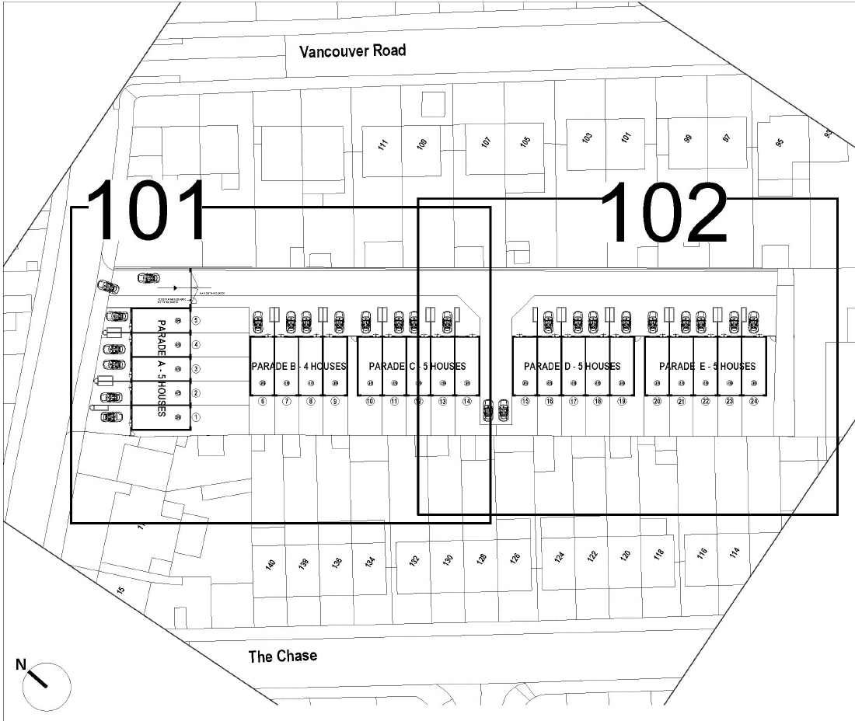
APPENDIX 3: SITE PHOTOGRAPHS

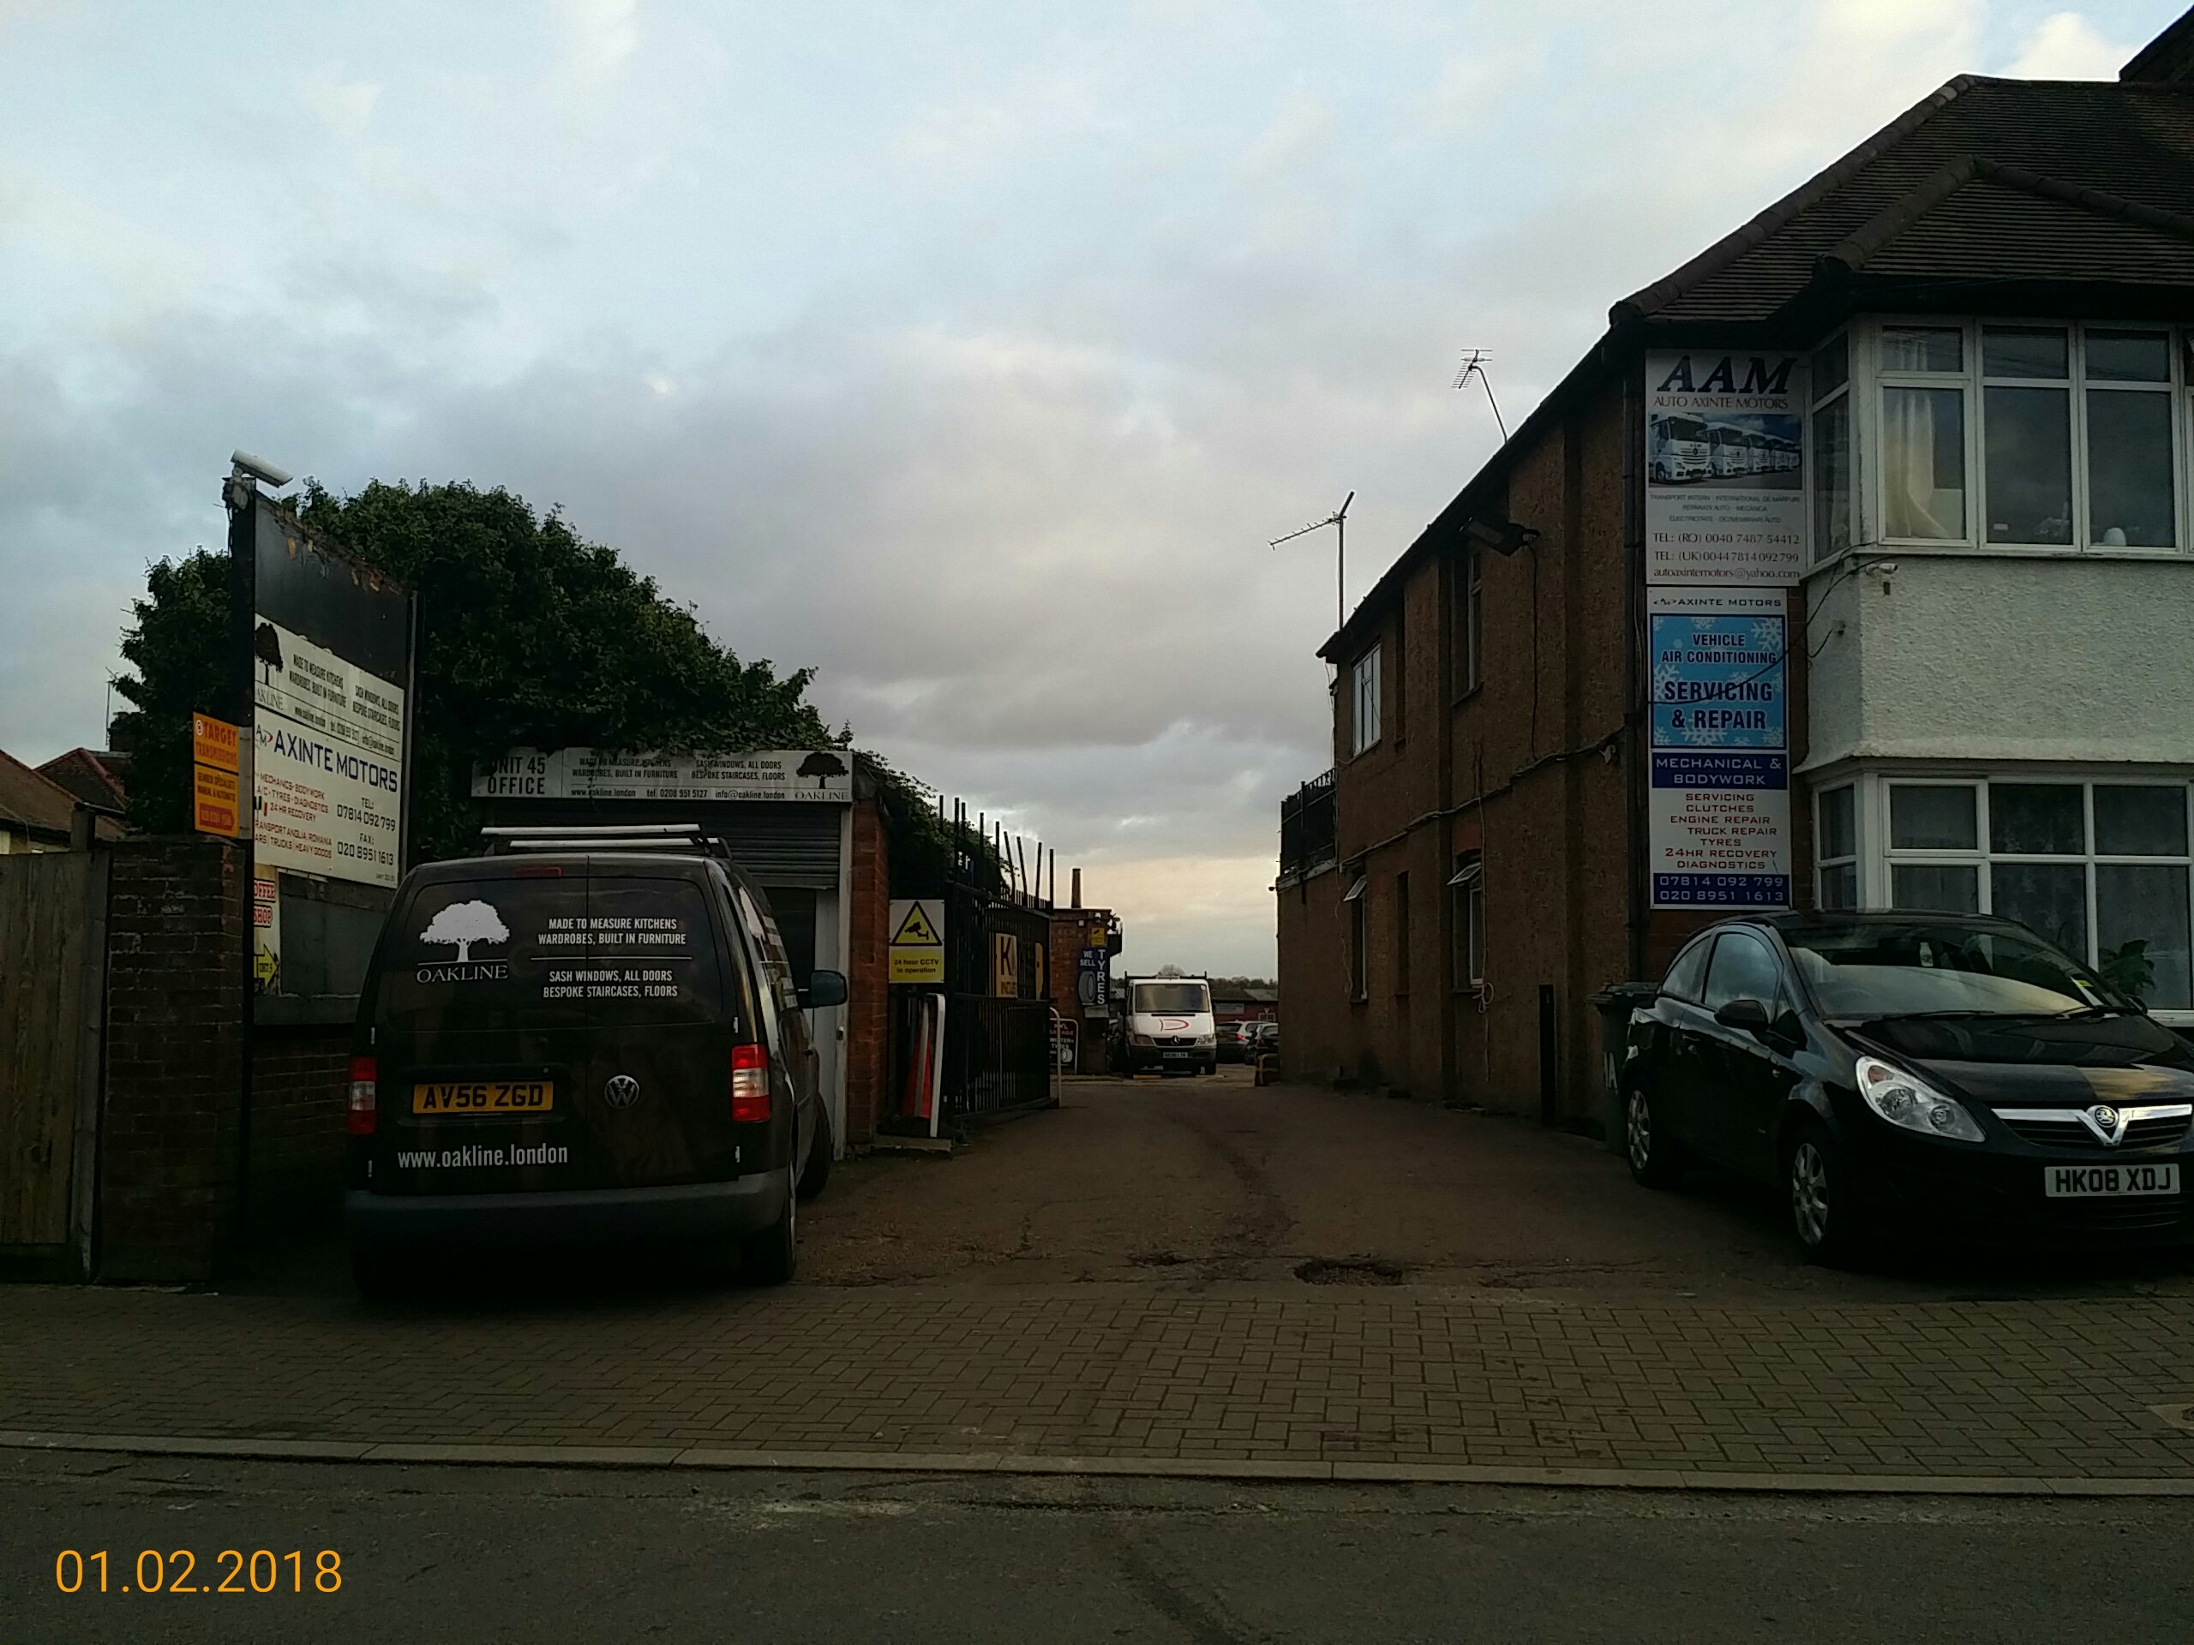
Existing entrance to the site
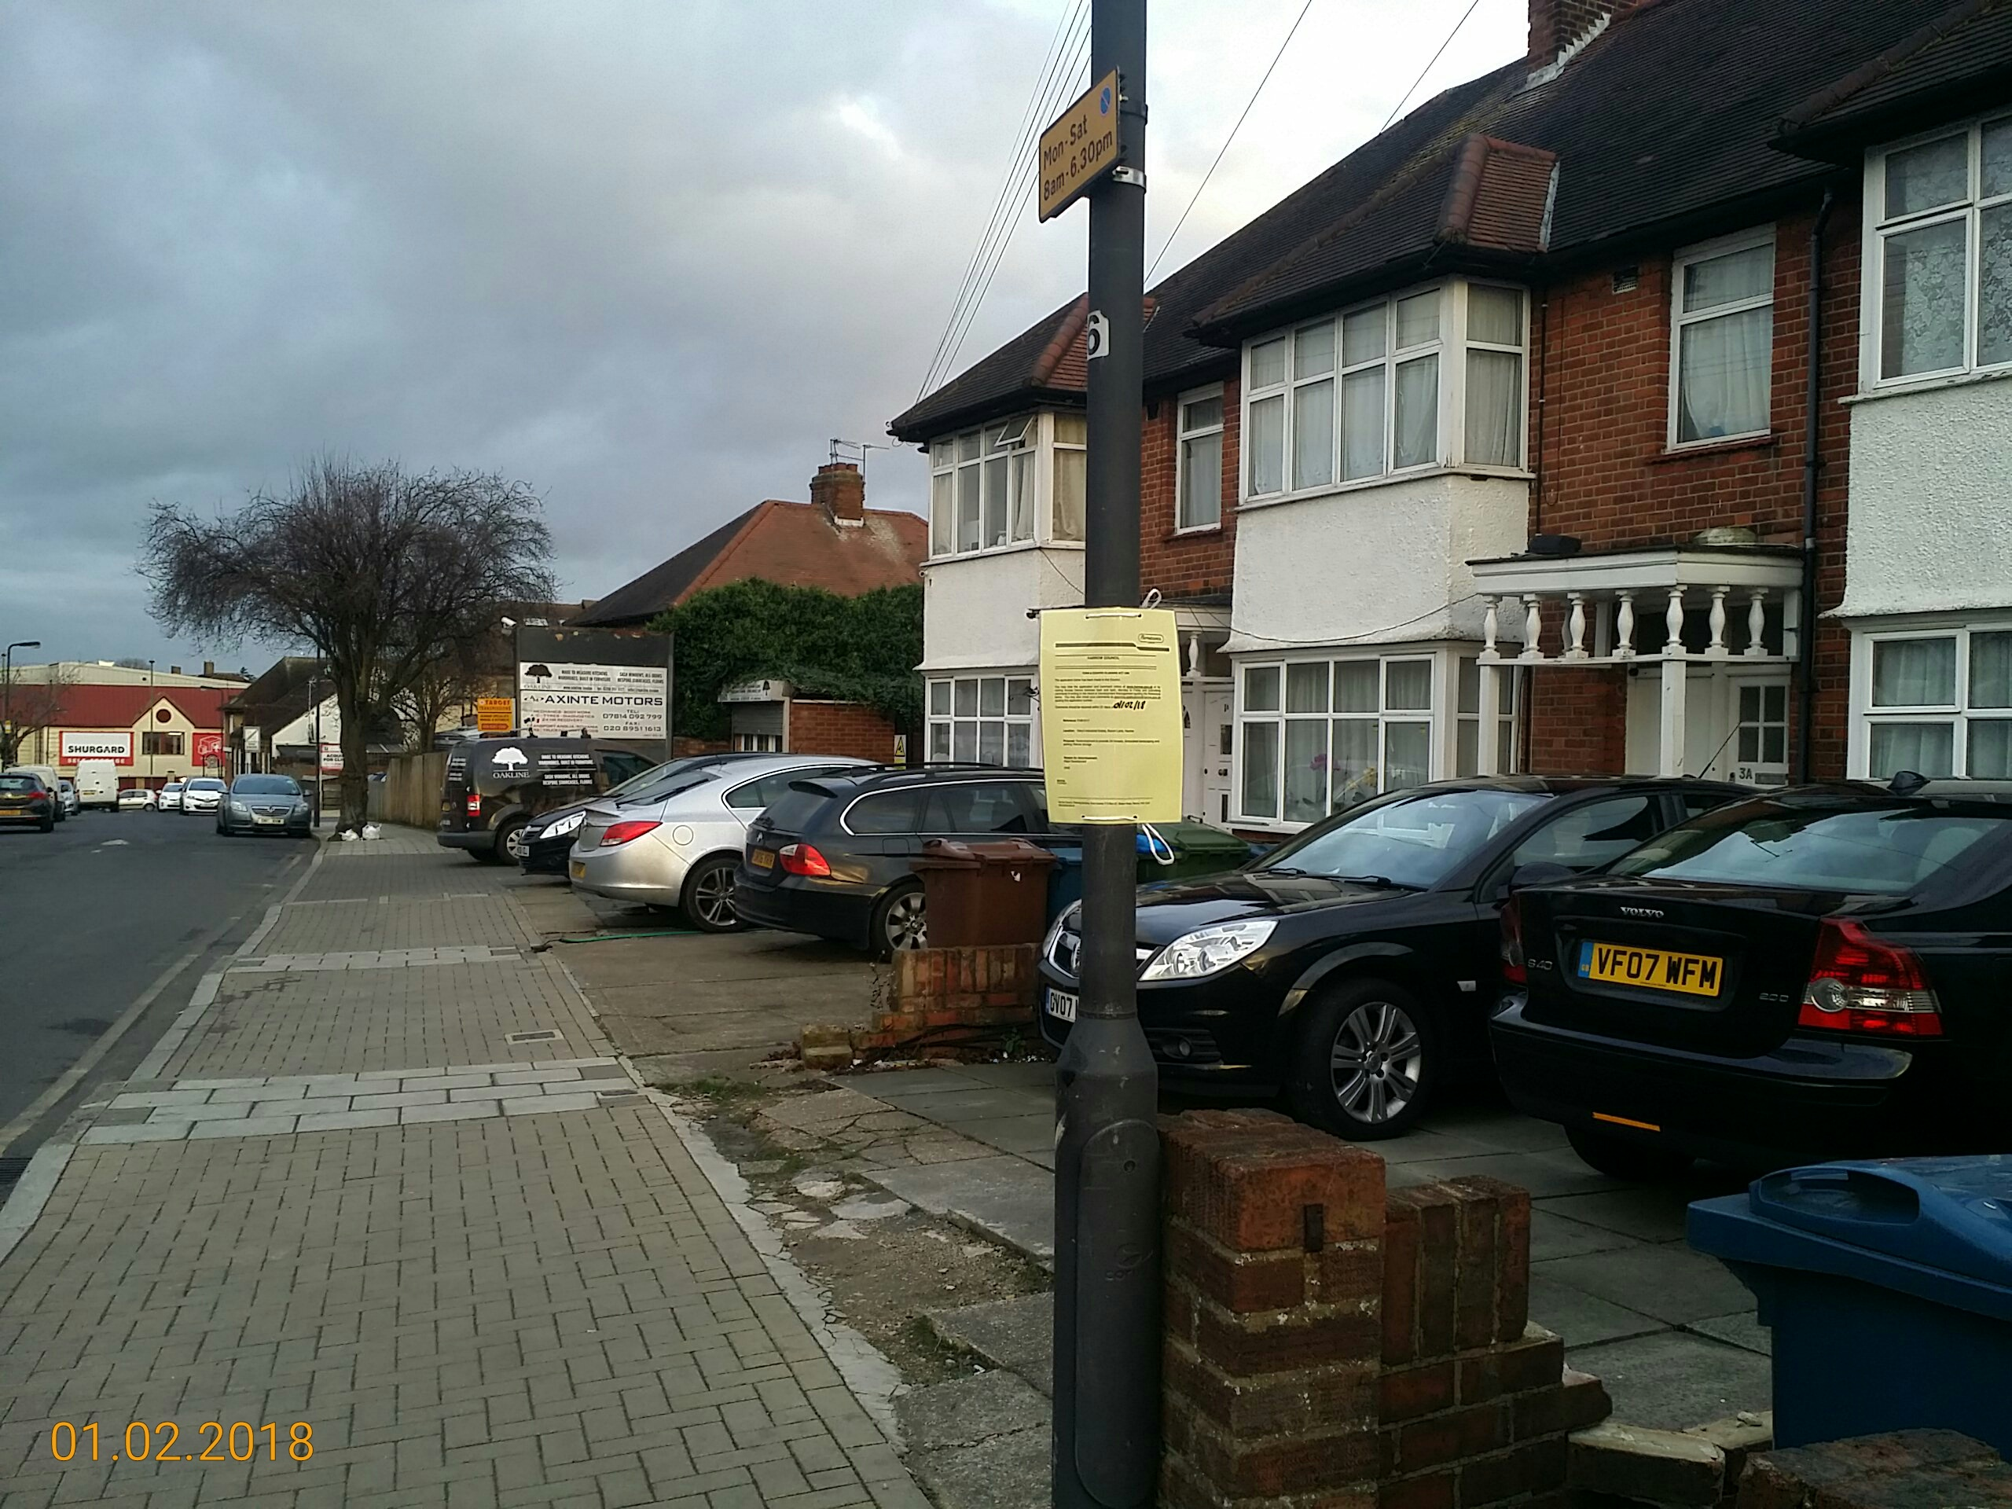
Properties 1 -5 Bacon Lane to be demolished
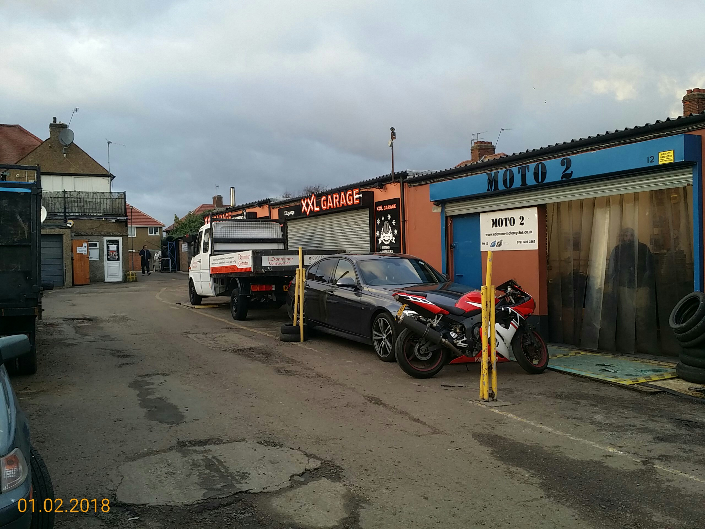
Existing uses within the site
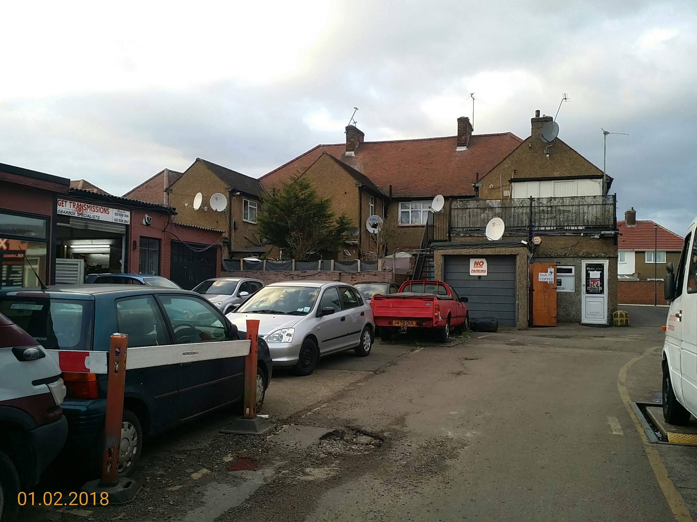
Rear of properties on Bacon Lane

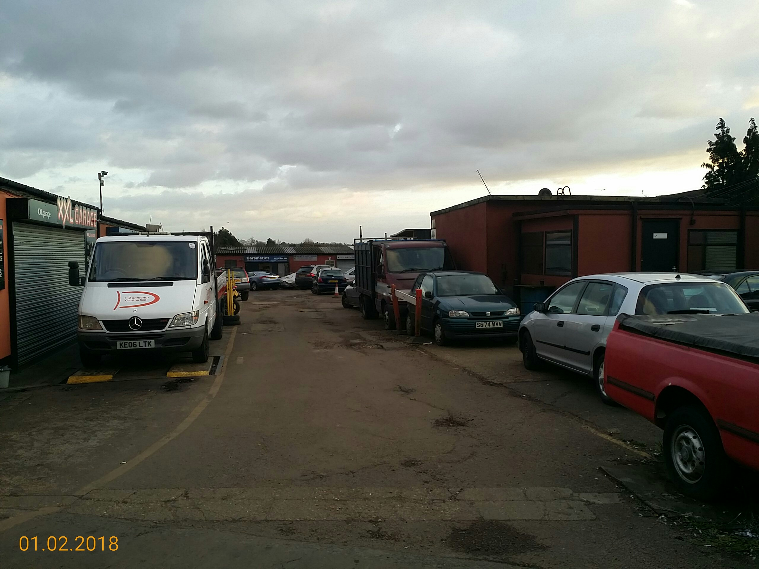

View of cars on site
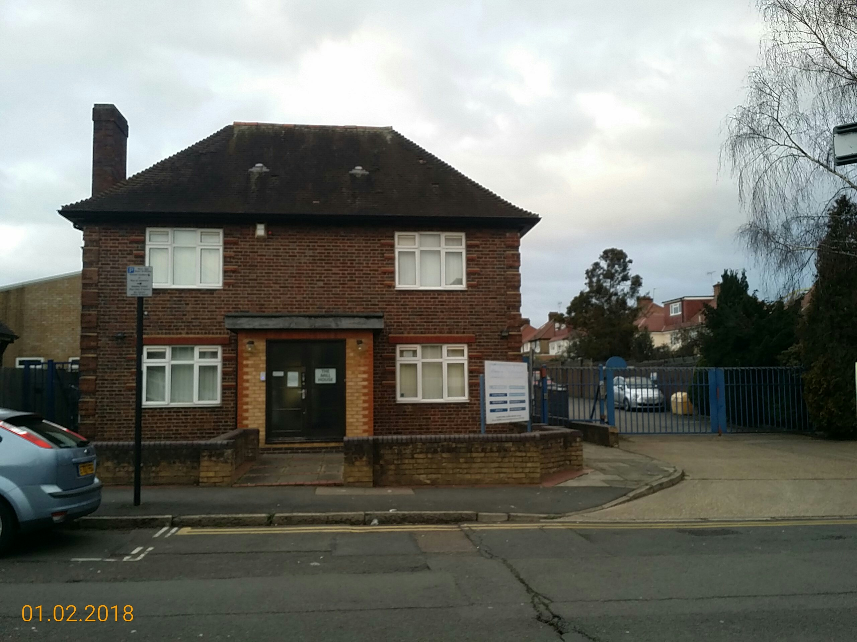
Rear of the rectangular land on Columbia Avenue
APPENDIX 4: PLANS AND ELEVATIONS

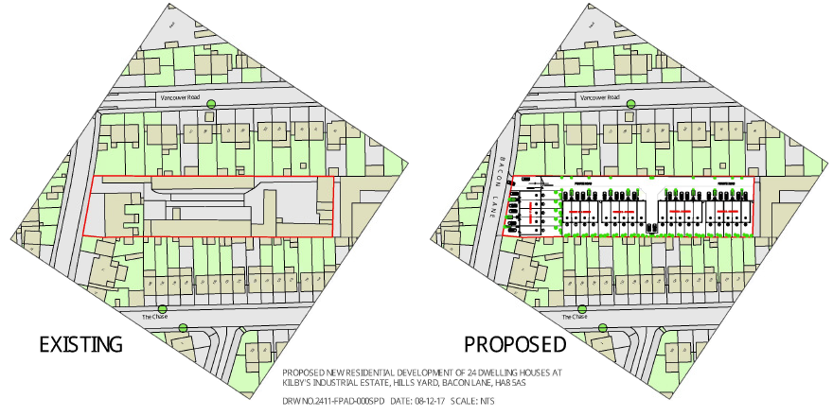
Existing and proposed site layout
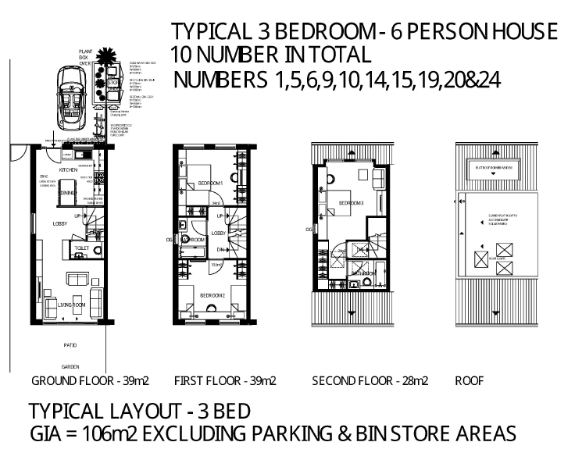
Layout for the 3 bed 6 person units
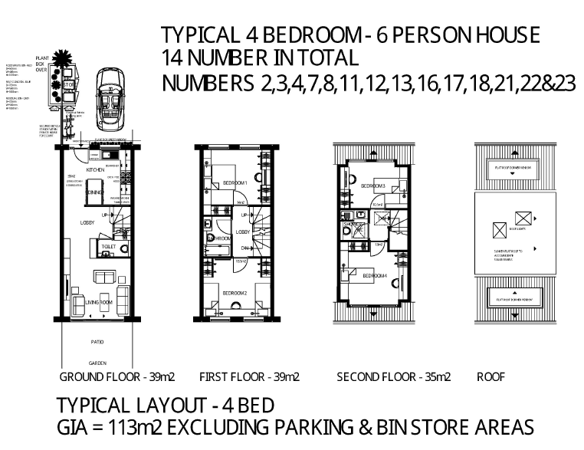
Layout for the 4 bed 6 person units
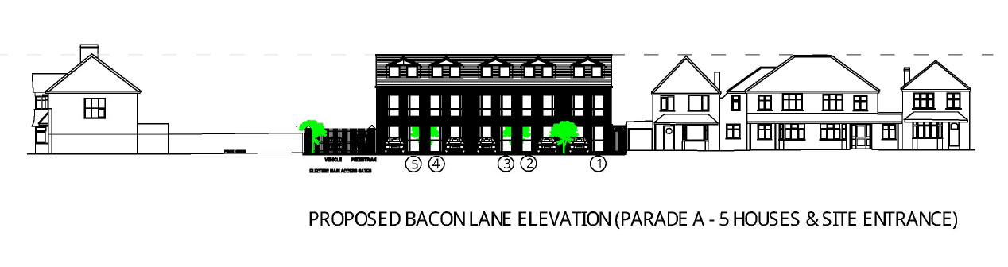
Proposed Bacon Lane elevation
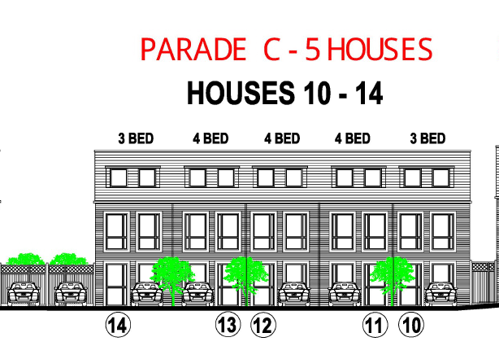
Terrace of 5 dwellinghouse numbered 10 -14
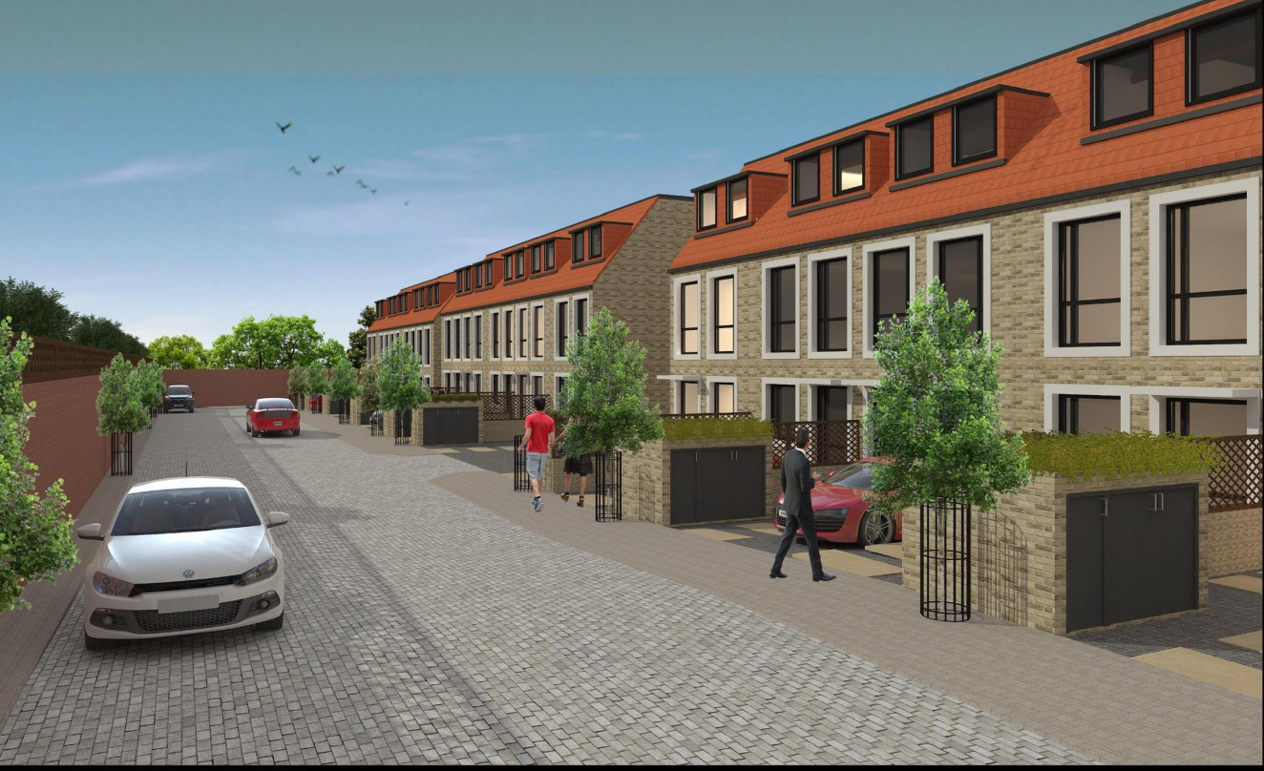
3D Image of driveway view

This page has been left intentionally blank

That portion of the Borough’s growth that would be accommodated beyond the Harrow & Wealdstone Intensification Area.
For the Edgware and Burnt Oak sub area.
‘Urban’ is defined as: areas with predominantly dense development such as, for example, terraced houses, mansion blocks, a mix of different uses, medium building footprints and typically buildings of four to six storeys, located within 800 metres walking distance of a district centre or along main arterial routes.
Calculated as: 24 dwellings divided by 0.328ha x 1ha.
Calculated as: 134 habitable rooms divided by 0.328ha x 1ha.

